Data Communications

Assignment Element 1 & 2

Student ID no. 21359035

Introduction

Basically we have a network which is devices such as computers connected to each other. One of these networks is a wide area network called the internet. Devices such as computers communicate with each other when connected. Since it is interesting how networks work Iwill go into further detail using terms or words to describe how they work.

There are devices in a network called servers which connect computers to communicate with each other for example sending emails. A mail server is used for this common method of communication.

Devices ae connected to each other to send data to each other which is how the internet and email works. There are terms such as protocols and packets which describe how data is sent between devices in a network. A protocol is the way a message is sent between devices on a network such as email messages. It is the type of message being sent between computers (such as the format of the message), the way it is sent and received and the response to the message when it is received. In a network such as the internet the protocols are the machines which are the hardware and software, communicating with each other. Protocols are the way devices communicate with each other when connected.

Examples of protocols being used between connected devices are TCP (transmission control protocol), HTTP (hypertext transfer protocol) and SMTP (simple mail transfer protocol). The transmission control protocol and hyper text transfer protocol are used by a computer connected to the internet. A user connected to the internet goes to a website by typing in the web address in the browser software and the HTTP protocol is the way the website is sent to the user by the server. The protocol is the request of the website sent by the user to server and the server responding to the request by sending a live copy of the website to the user.

The simple mail transfer protocol is a simple protocol used for sending emails between computers on a network. The protocol is the email being sent from a computer to the computer it is connected to via a mail server. Once the connected computer receives the email action is taken such as a reply to the email message and then the reply is sent via the mail server to the sender. The SMTP can also be a response to an email message sent from a computer as a receipt telling the sender if the message was received or not. The Transmission Control protocol is the transmission of messages sent between devices on a network. It is the way emails are transmitted with the SMTP protocol while being sent and responded to. When a user on the internet requests a webpage with images the TCP is the transmission of the webpage with the images sent as a reply from the server to the user.

Another type of protocol is DNS which stands for Domain Name System. This is about the address of a webpage requestsed by a user connected to the internet. When the user requests a webpage a database known as a DNS database is connected to to get the IP address of the web address stored in the database while the rquested webpage is being sent to the user. Suppose the user requests the website [www.afternerd.com](http://www.afternerd.com) by typing it in their browser. The address [www.afternerd.com](http://www.afternerd.com) is the domain name and afternedr.com is the subdomain. The web address has an IP address say like 123.234.34.55 stored in the DNS database which is stored in a server known as a DNS server. Infact every device connected to a network is identified by an IP address so that they can be accessed.

The other term packets or data packets are the pieces of data being sent between devices. Data being sent between computers on a network are broken down into chunks known as packets and the purpose of the first part of this assignment is to show data is being sent and received by devices connected to each other. To do this we first need a software on the computer called Wireshark which detects data packets while the computer is connected to a network such as the internet. The software captures data packets being sent to and received by the computer it is installed on. It is basically a packet sniffing tool or “packet sniffer” that ‘sniffs’ chunks of data being sent and received by the computer. I will be using this software in this assignment to show the packets captured by it and mention what the details of the captured packet show.

You can check what network or devices your computer is connected to and details of these connections such as servers by typing commands on the Command Prompt. A user can type commands as queries to get details of servers including their name and IP addresses from DNS servers. There are tools you can use in the prompt by typing the command in all one word and in all one word with options.

1. Run nslookup to obtain the IP address of a Web server in Asia. What is the IP address of that server?

So here we start using the nslookup tool in Windows in the Command Prompt to get the IP address of a server holding a web page in another location. This is by typing a command known as nslookup followed by the web page address on the command line shown in the screenshot below.

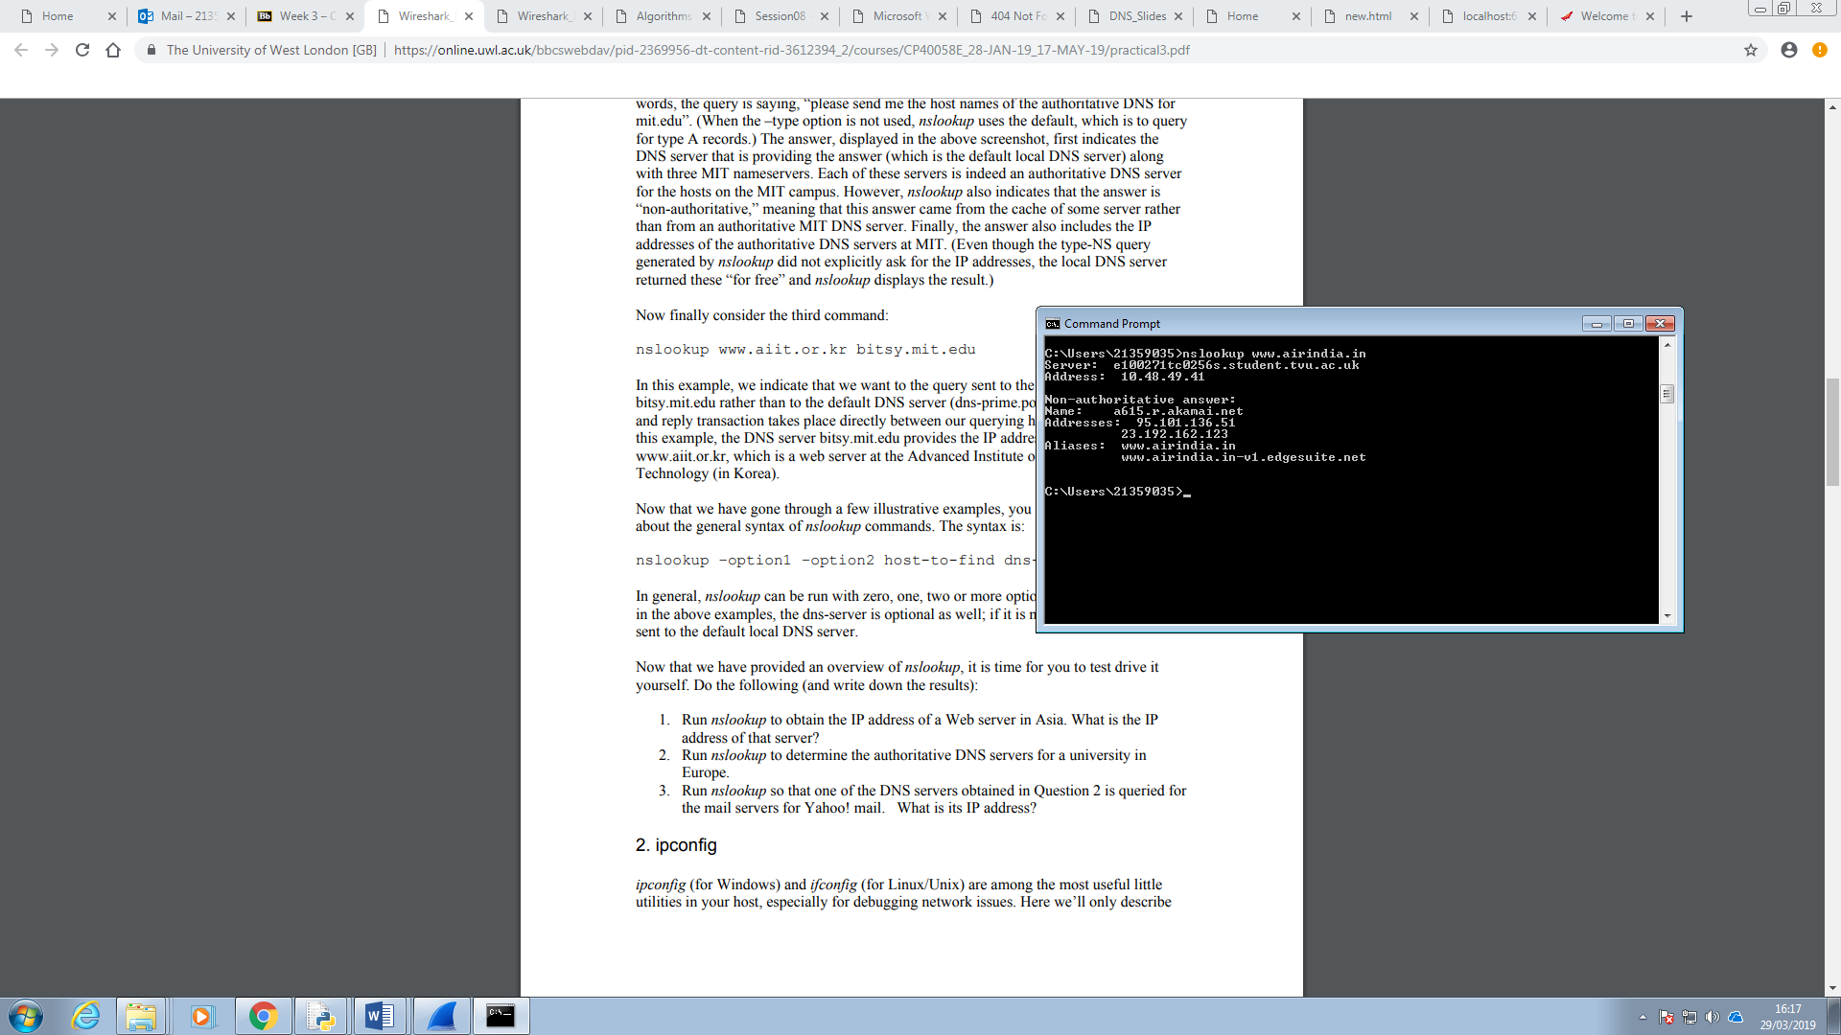

The screenshot above shows the IP address of a web server obtained in Asia is 95.101.136.51(which is usually the first one even though I have got the addresses of two web servers).

2. Run nslookup to determine the authoritative DNS servers for a university in Europe.

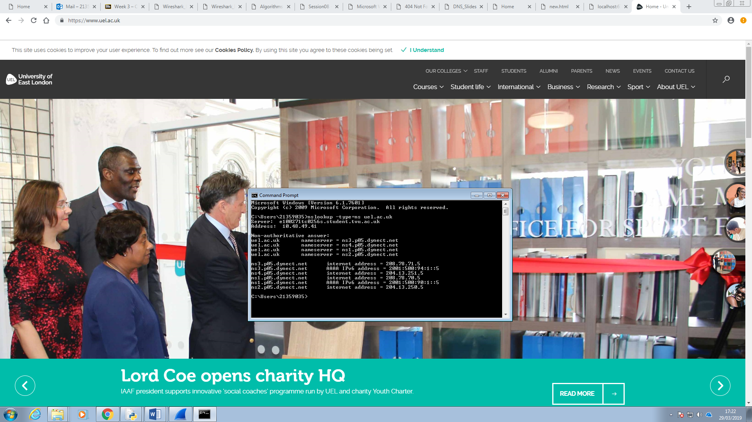

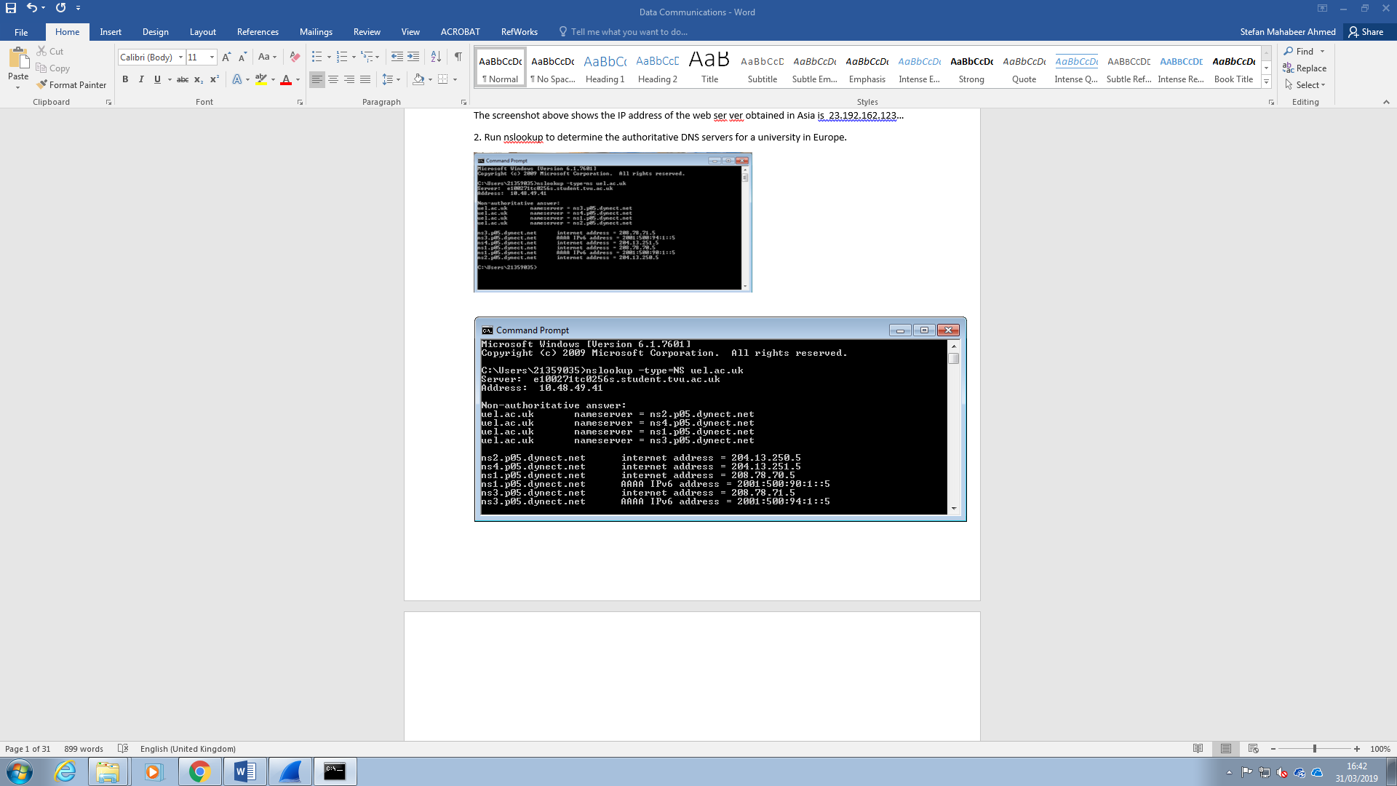

The command used here was nslookup with the option “–type=NS” and the domain uel.ac.uk(the address without using www.).

The nslookup command sends a query to the local DNS server for a record of authoritative DNS servers for the hosts at the uel site. The list of host names are provided here of the authoritative DNS servers with their IP addresses. The record is indicated as Non-authoritative by nslookup since the record has come from the cache of a server which is not an authoritative uel DNS server. The cache is a table of DNS records, held by servers and clients, of servers with their names and IP address which have recently been received.

3. Run nslookup so that one of the DNS servers obtained in Question 2 is queried for the mail servers for Yahoo! mail. What is its IP address?

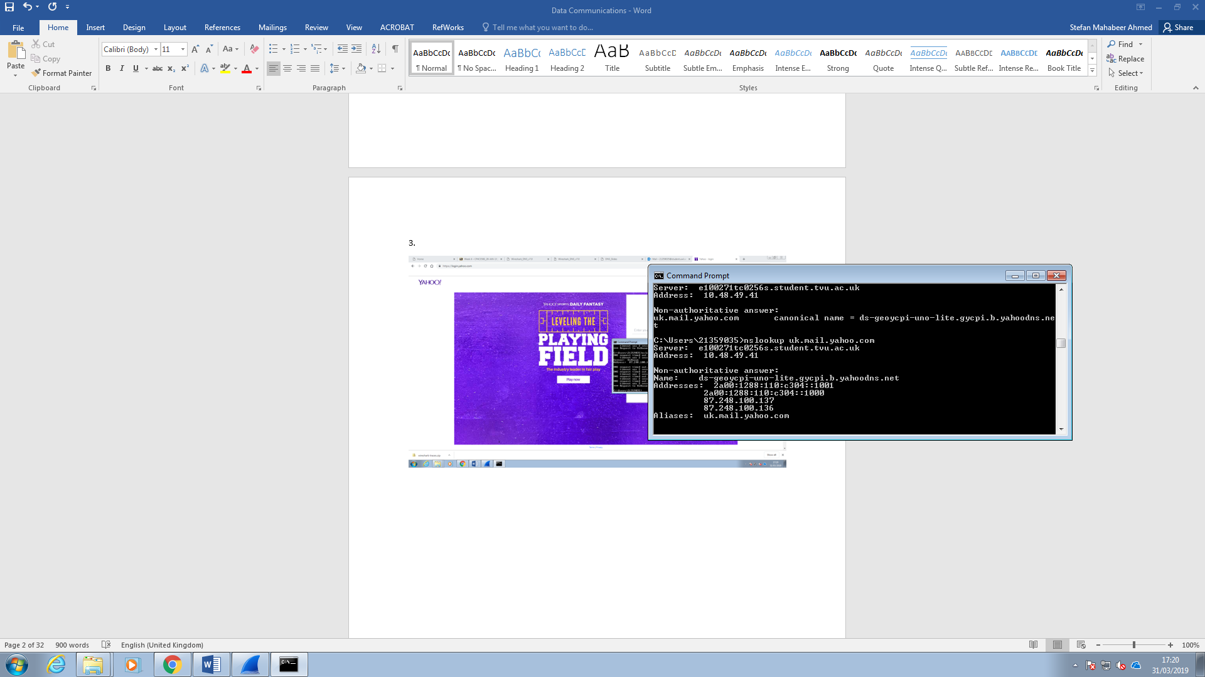

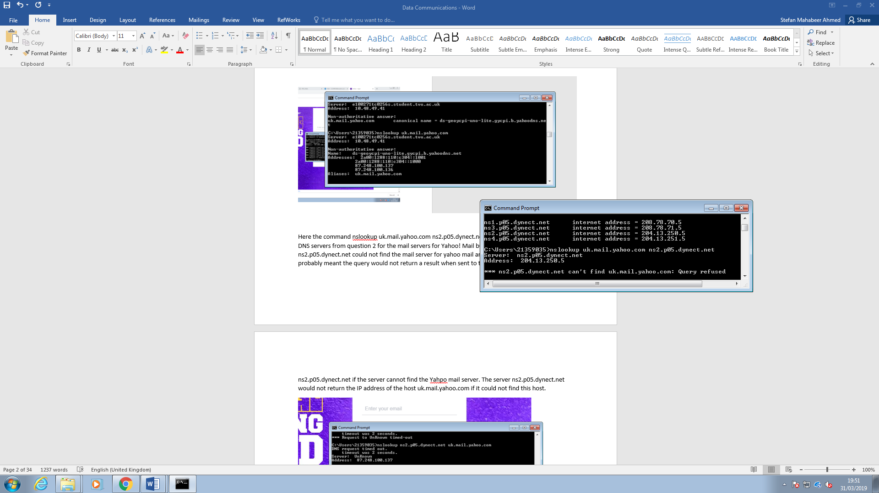

Here the command nslookup uk.mail.yahoo.com ns2.p05.dynect.net was used to query one of the DNS servers from question 2 for the mail servers for Yahoo! Mail but I got the result saying ns2.p05.dynect.net could not find the mail server for yahoo mail and the query was refused. This must mean the query would not return a result when sent to the uel DNS server ns2.p05.dynect.net if the server cannot find the Yahpo mail server. The server ns2.p05.dynect.net would not return the IP address of the host uk.mail.yahoo.com if it could not find this host.

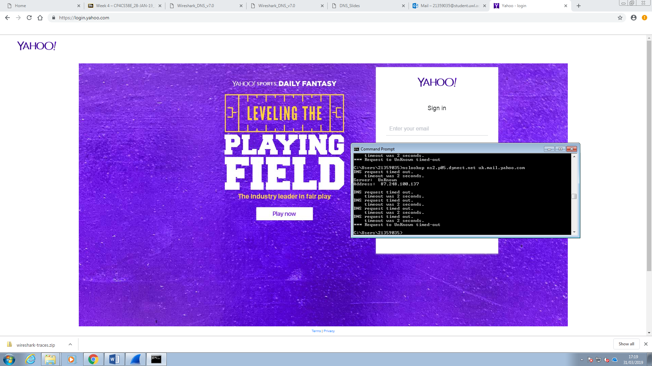

I then did it the other way round with ns2.p05.dynect.net as the host sending the query to uk.mail.yahoo.com but the result was the DNS request being timed out and the address of an unknown server rather than the Yahoo mail server.

To fix this problem I used the google public server 8.8.8.8 with the nslookup command and uk.mail.yahoo.com as nslookup uk.mail.yahoo.com 8.8.8.8 shown below.

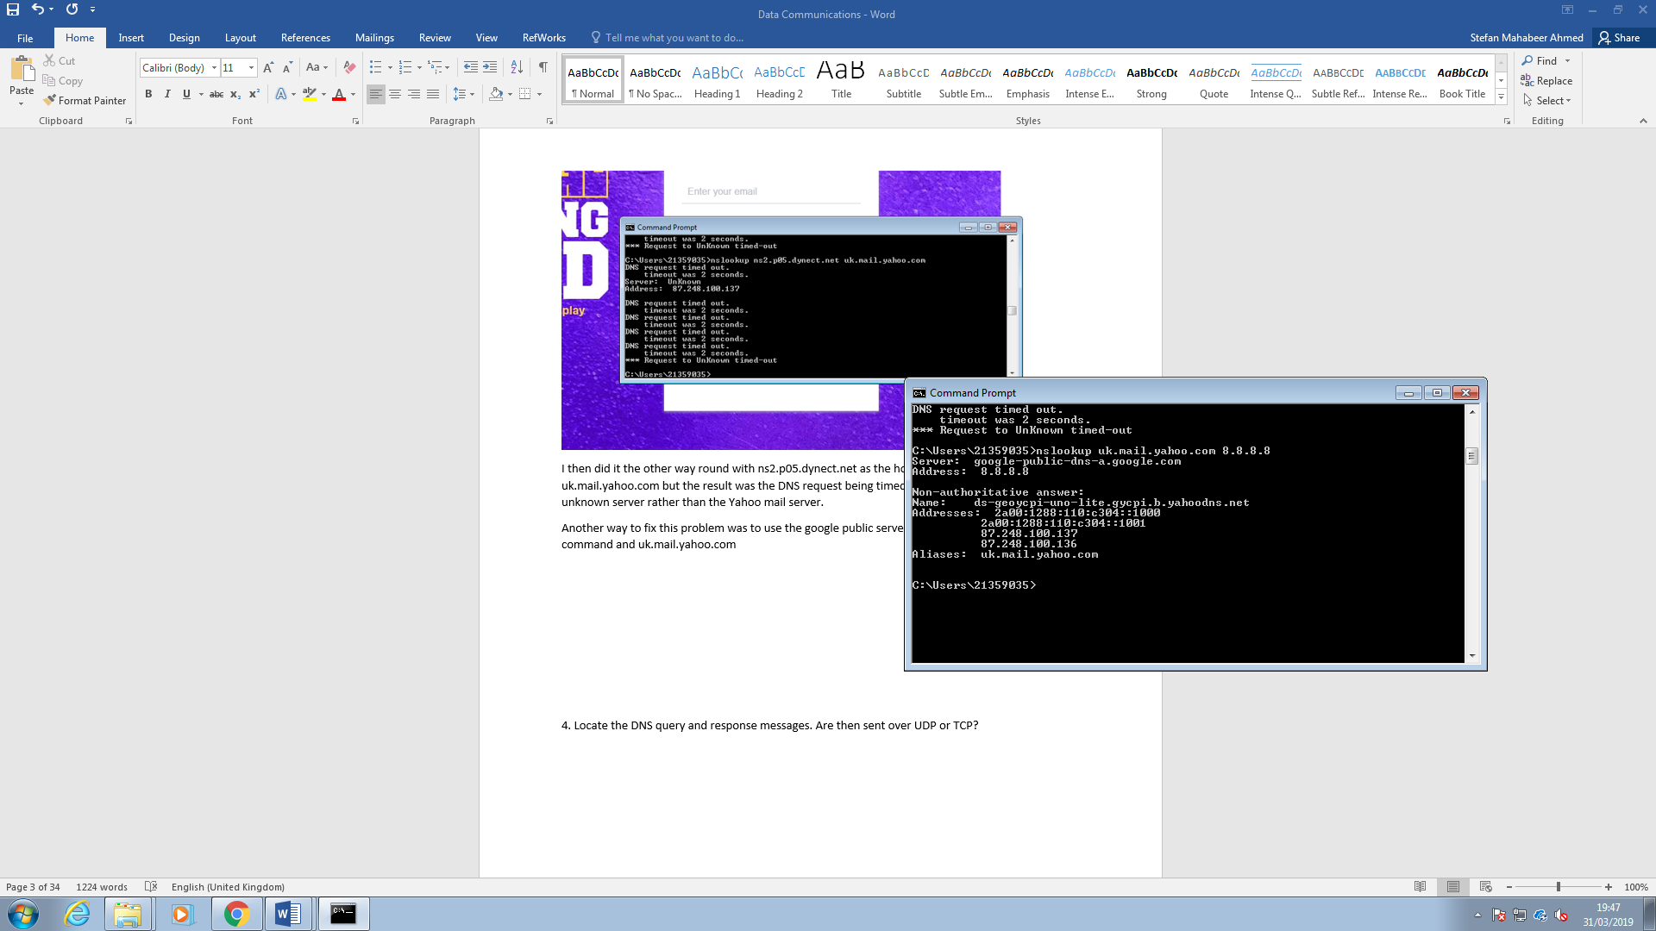

The IP address is 87.248.100.137(which is usually the first one).

Back to the software on the computer Wireshark, that is used to capture or ‘sniff’data packets. We start here looking at lists of packets captured by the software while the computer was connected to the internet and a website on the internet was accessed. Data packets of the website accessed were captured as messages sent and received by the computer.

4. Locate the DNS query and response messages. Are then sent over UDP or TCP?

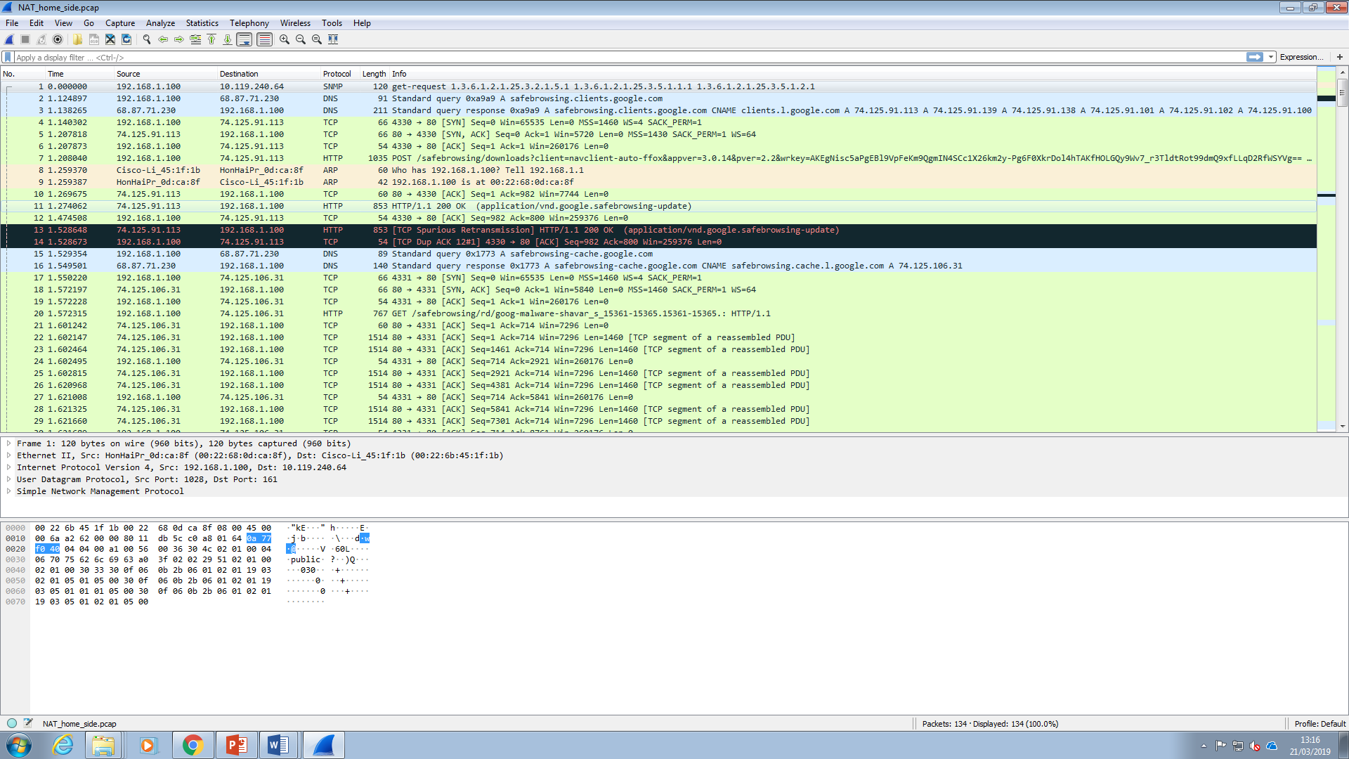

The screenshot above shows a packet trace file of the packet that was captured using the packet sniffing software called Wireshark.

Details of each packet is listed including the number time taken to capture the packet, the source i.e. where it’s coming from and the destination i.e. where it’s going, the protocol used to exchange the message and the information(Info) such as whether they are queries or response messages or use the GET or POST methods to send information to the client from the server.

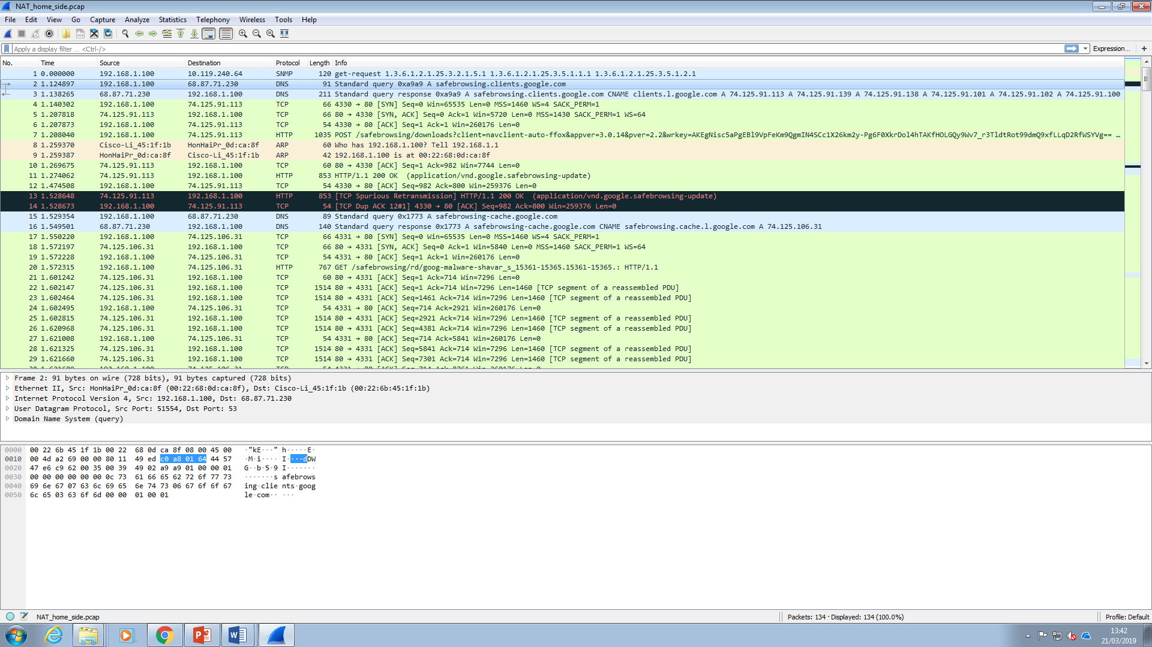

A close up of the packets captured on the trace file. The protocols used here are DNS, TCP and HTTP. DNS stands for Domain Name System which is used for the address of the website. The transfer control protocol os the TCP which is the protocol used to transfer the packet to and from the IP addresses.

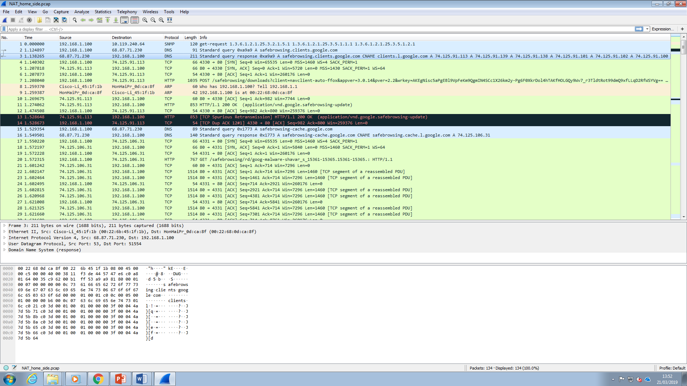

The question is to locate the DNS query and response messages. So here is a shot of the packets that used the DNS protocol.



The DNS Query and response messages are shown here. It says if the DNS message is a query or a response under the information(Info) column.

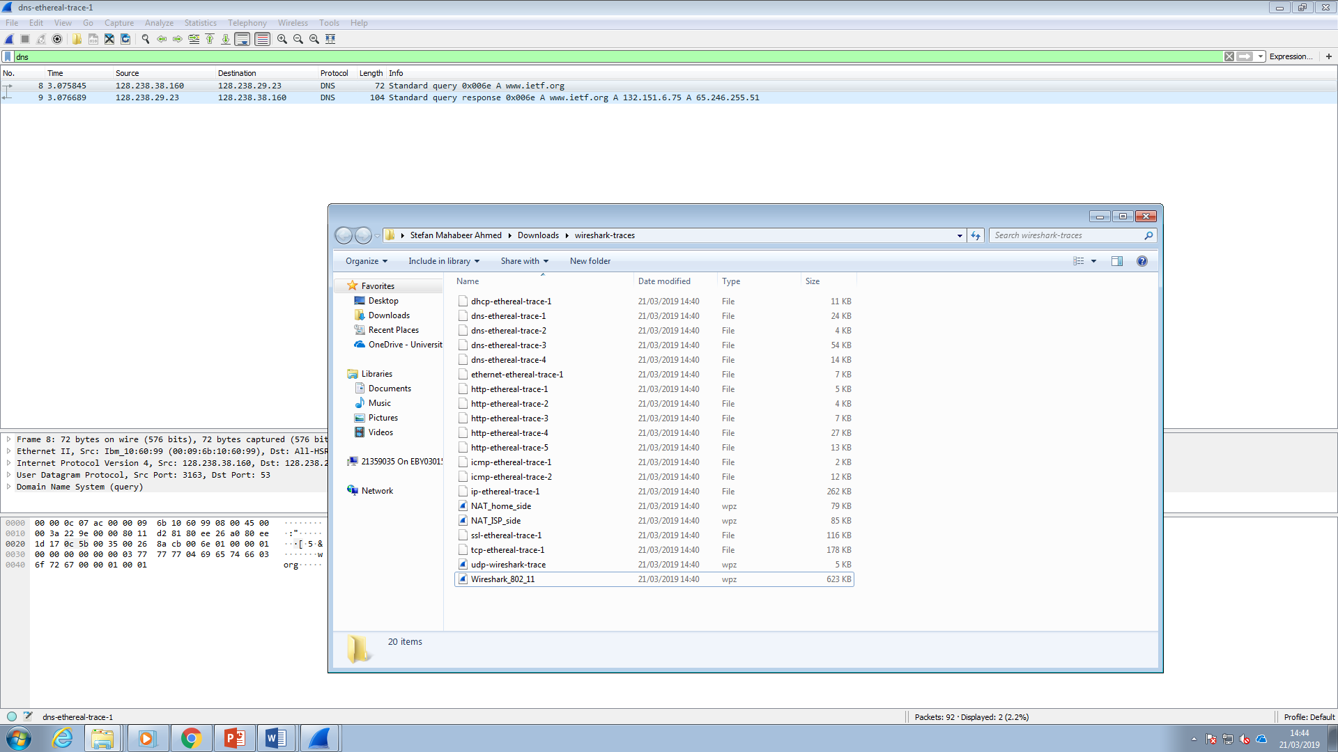

To answer the question here is the folder of trace files collected by Wireshark while following lab tasks on an author’s computer. The dns-ethereal-trace-1 file located at the top is the file to use which has all the details of the DNS packet that was captured.

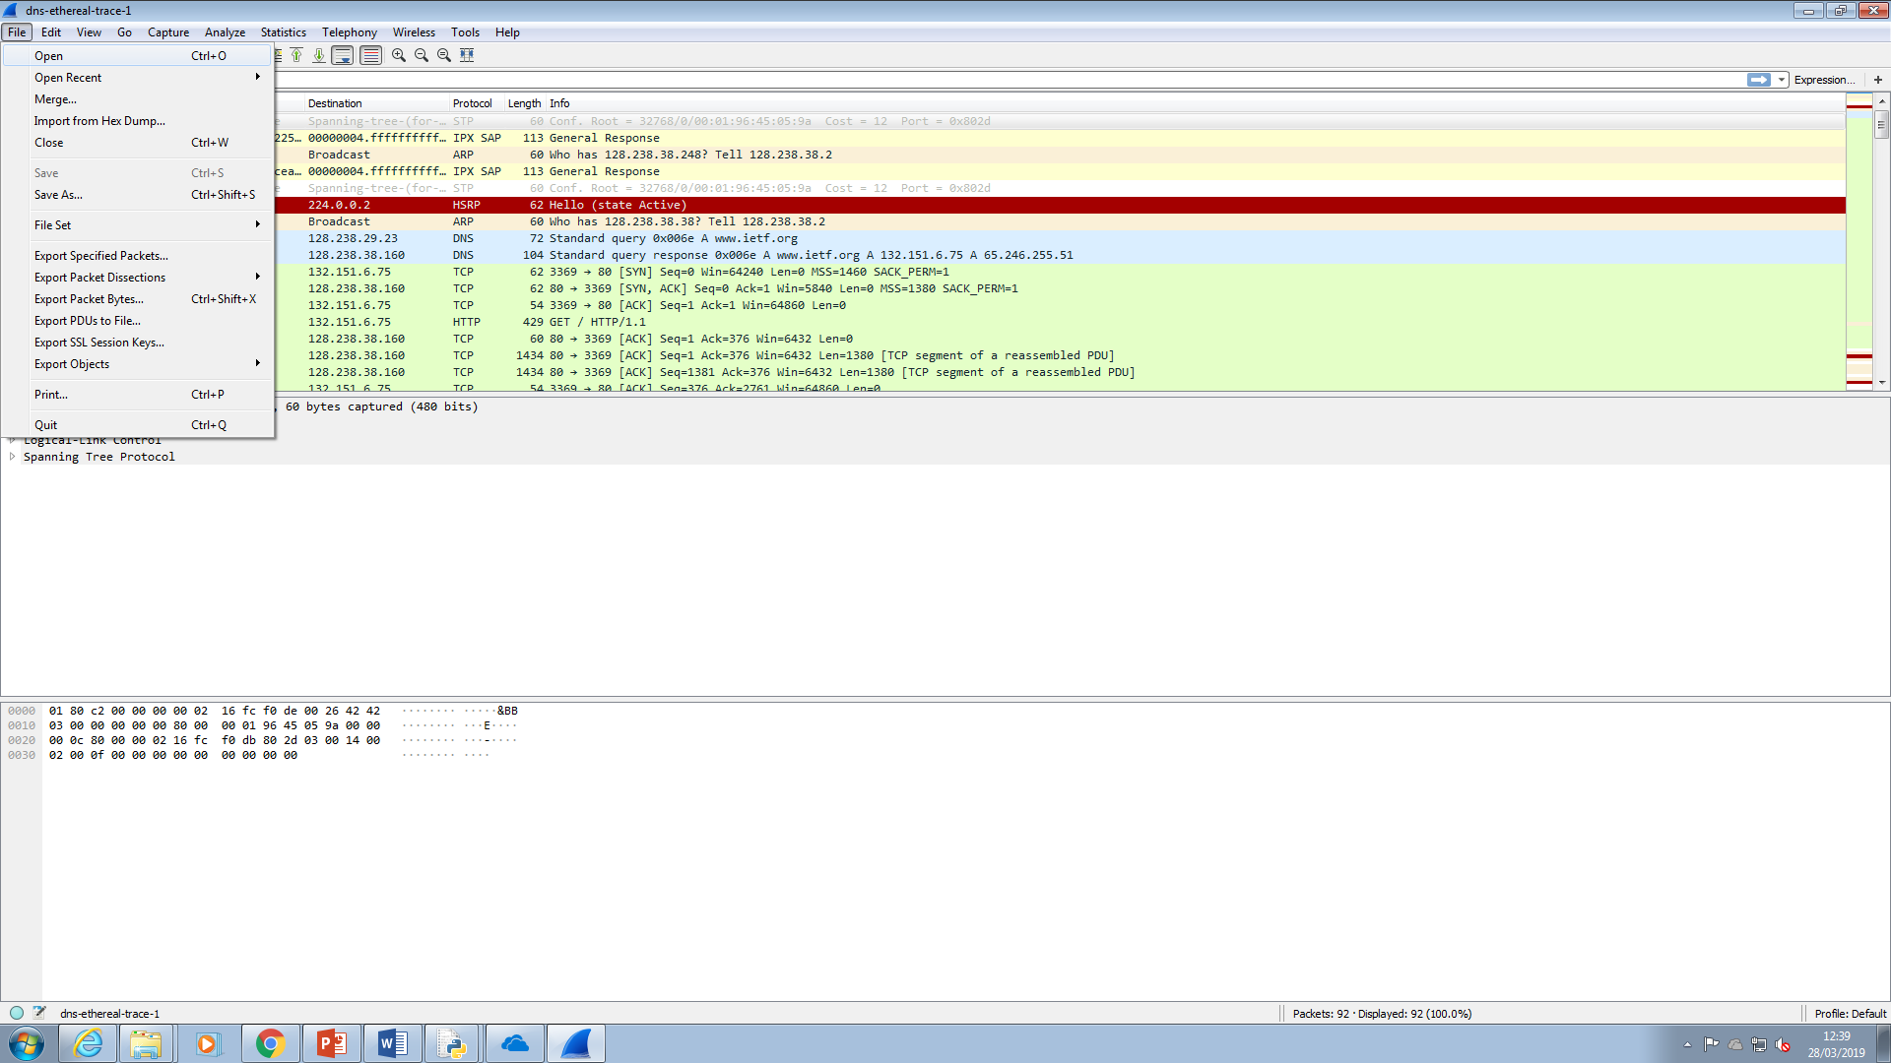

Back to Wireshark I go to File, Open to open a trace file called dns-ethereal-trace-1.

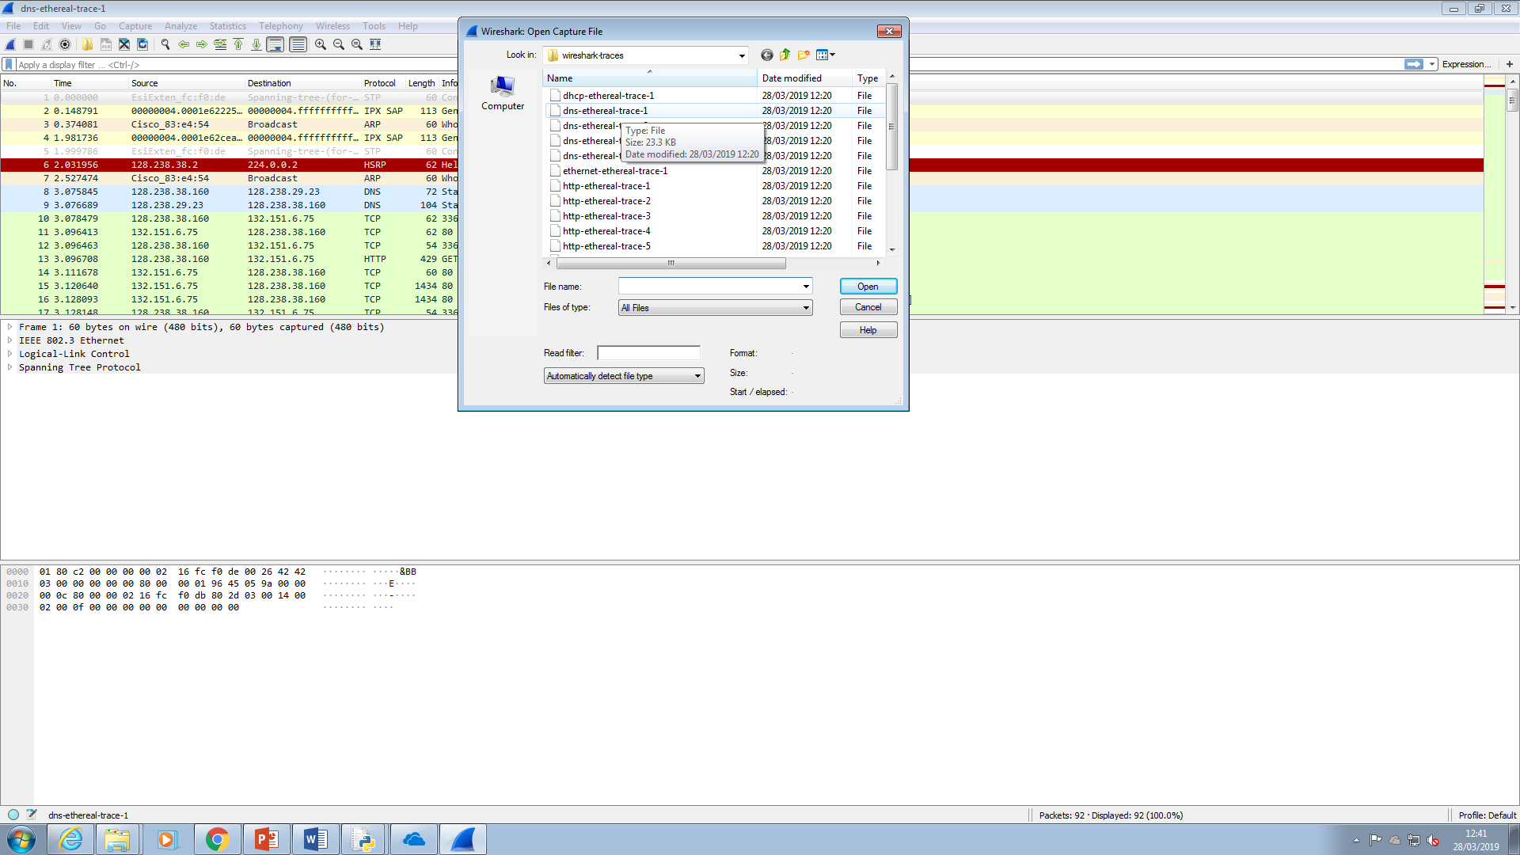

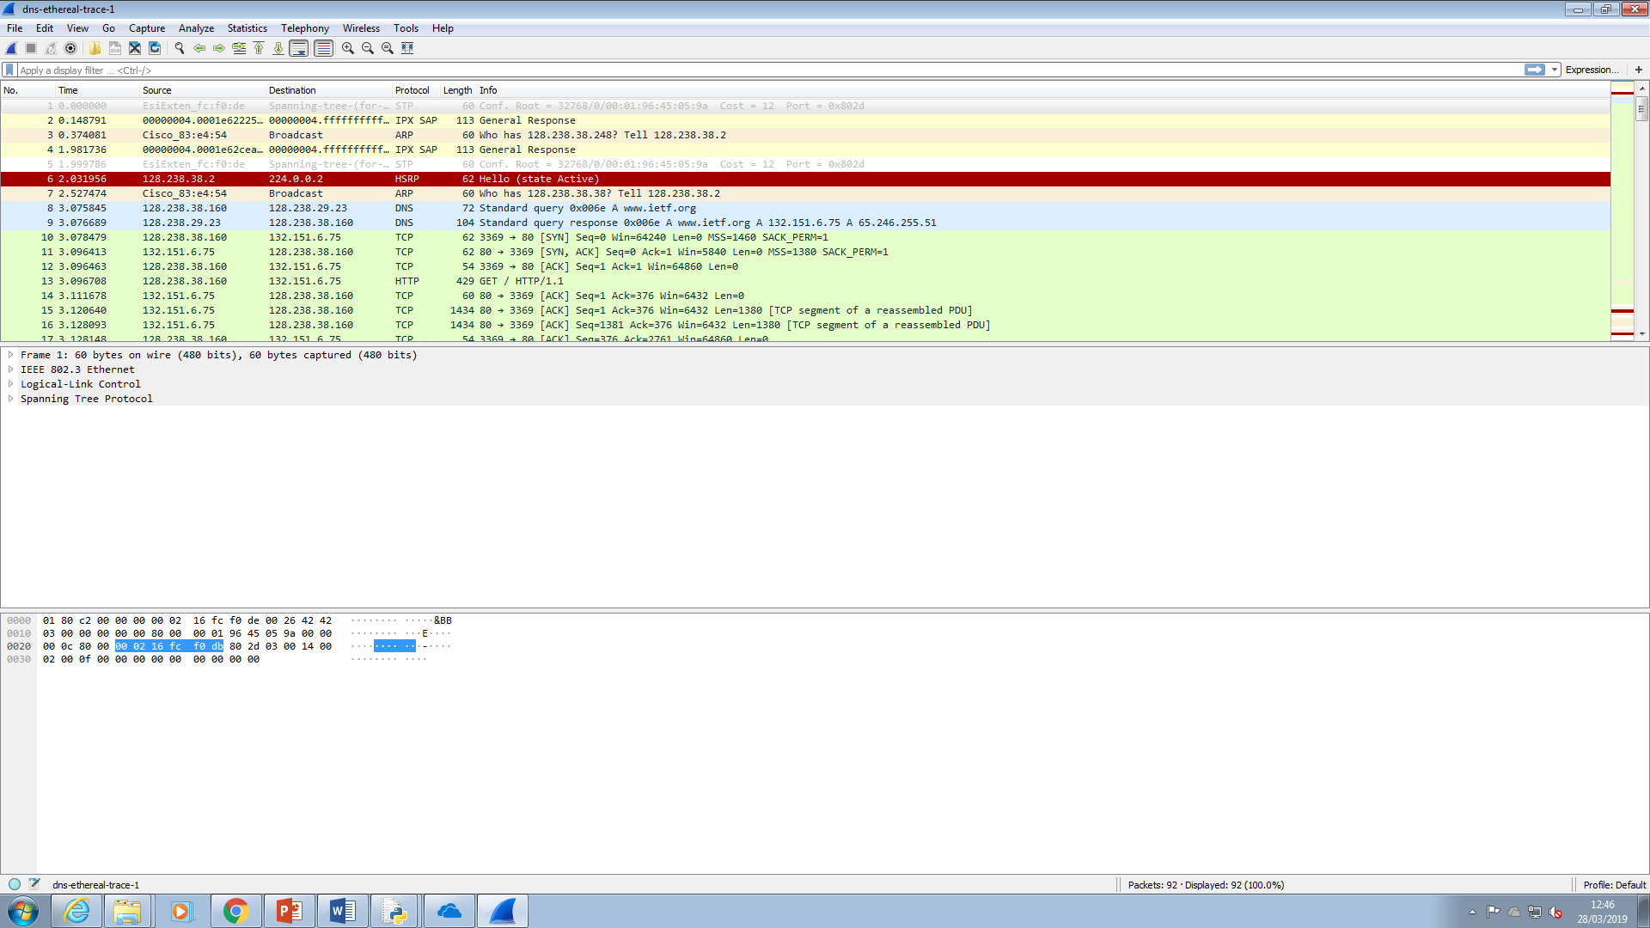

Details of the trace file are shown including a frame mentioning the size of the message captured in bits and bytes (in a shorter form of bits) and the type of interface it was sent over which in this case is Ethernet.

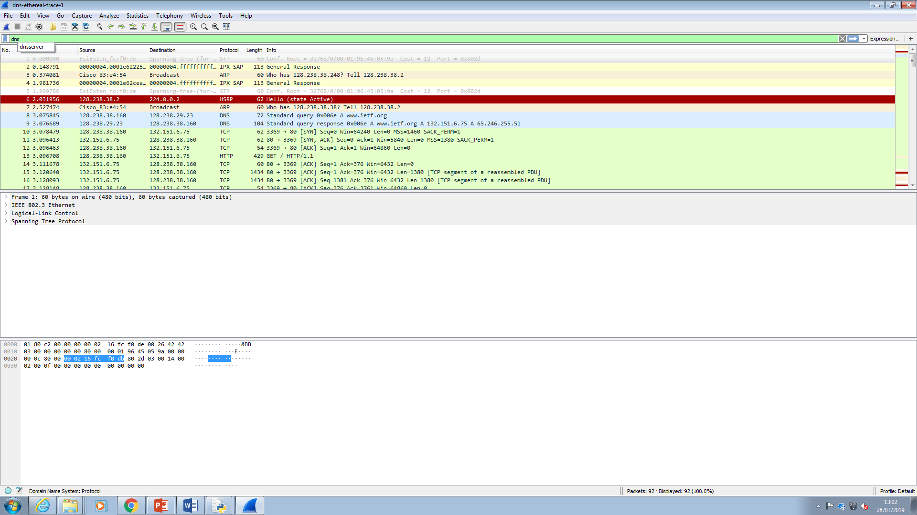

I type dns in the display filter box to filter the display to filter the display to show the packets captured that used the DNS protocol and press Enter.

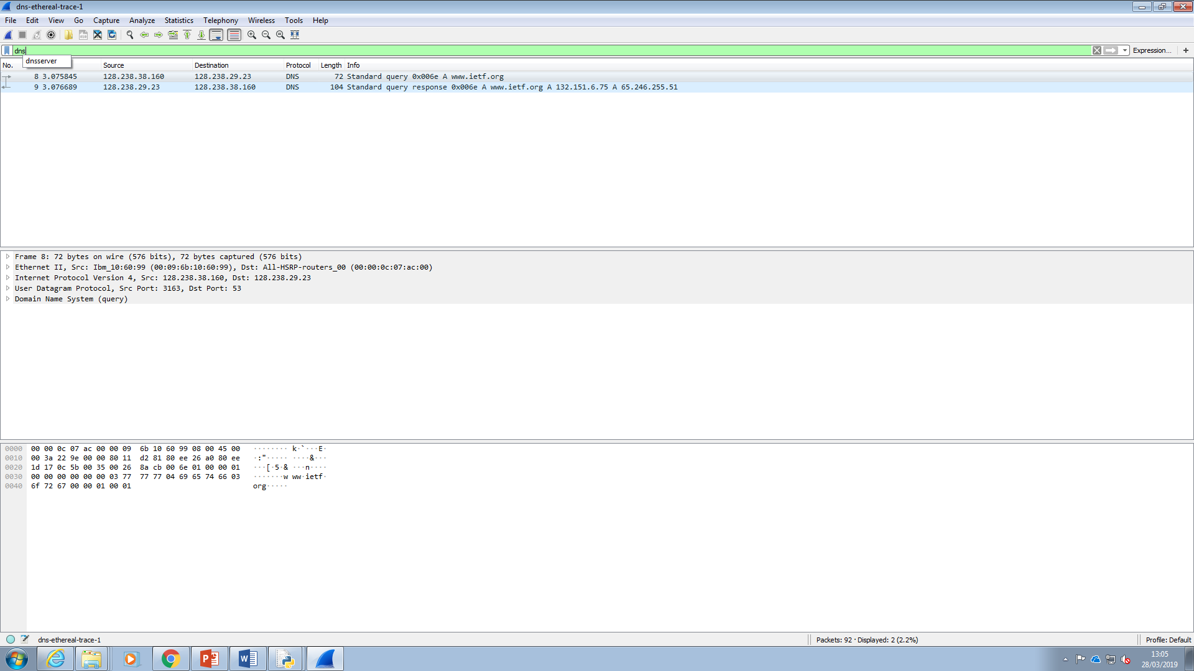

The DNS query and response messages are located here.

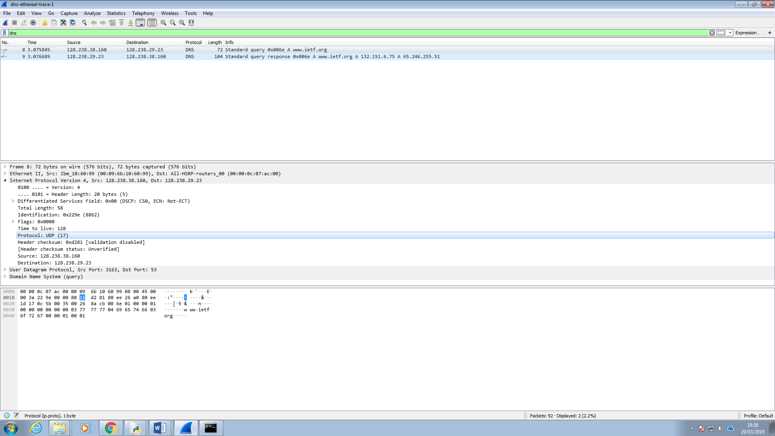

So by clicking on the message sent as a query I can look at the details of the message in the screenshot below.

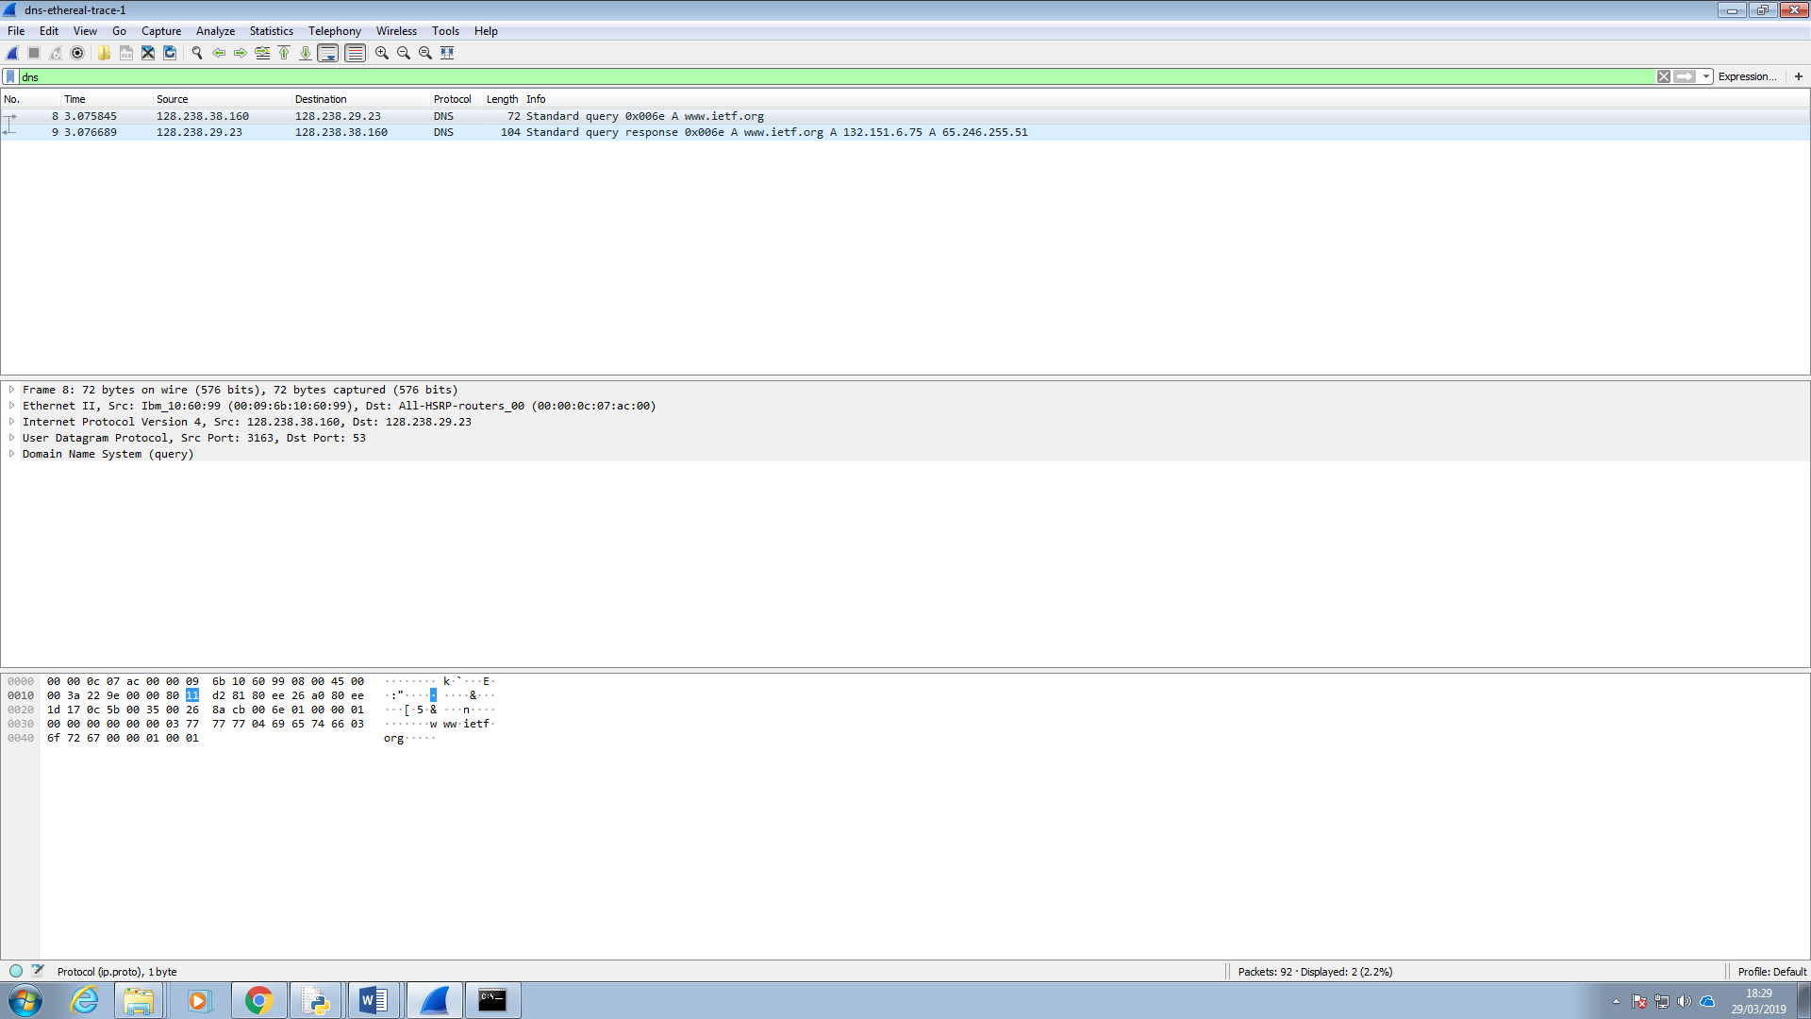

Here we have the Frame, Ethernet Internet Protocol, User Datagram and the DNS Query details to look at which are viewed by clicking on the triangle next to each of them. Clicking on the triangle next to Internet Protocol version 4 expands all the details of the internet protocol used to send the query.

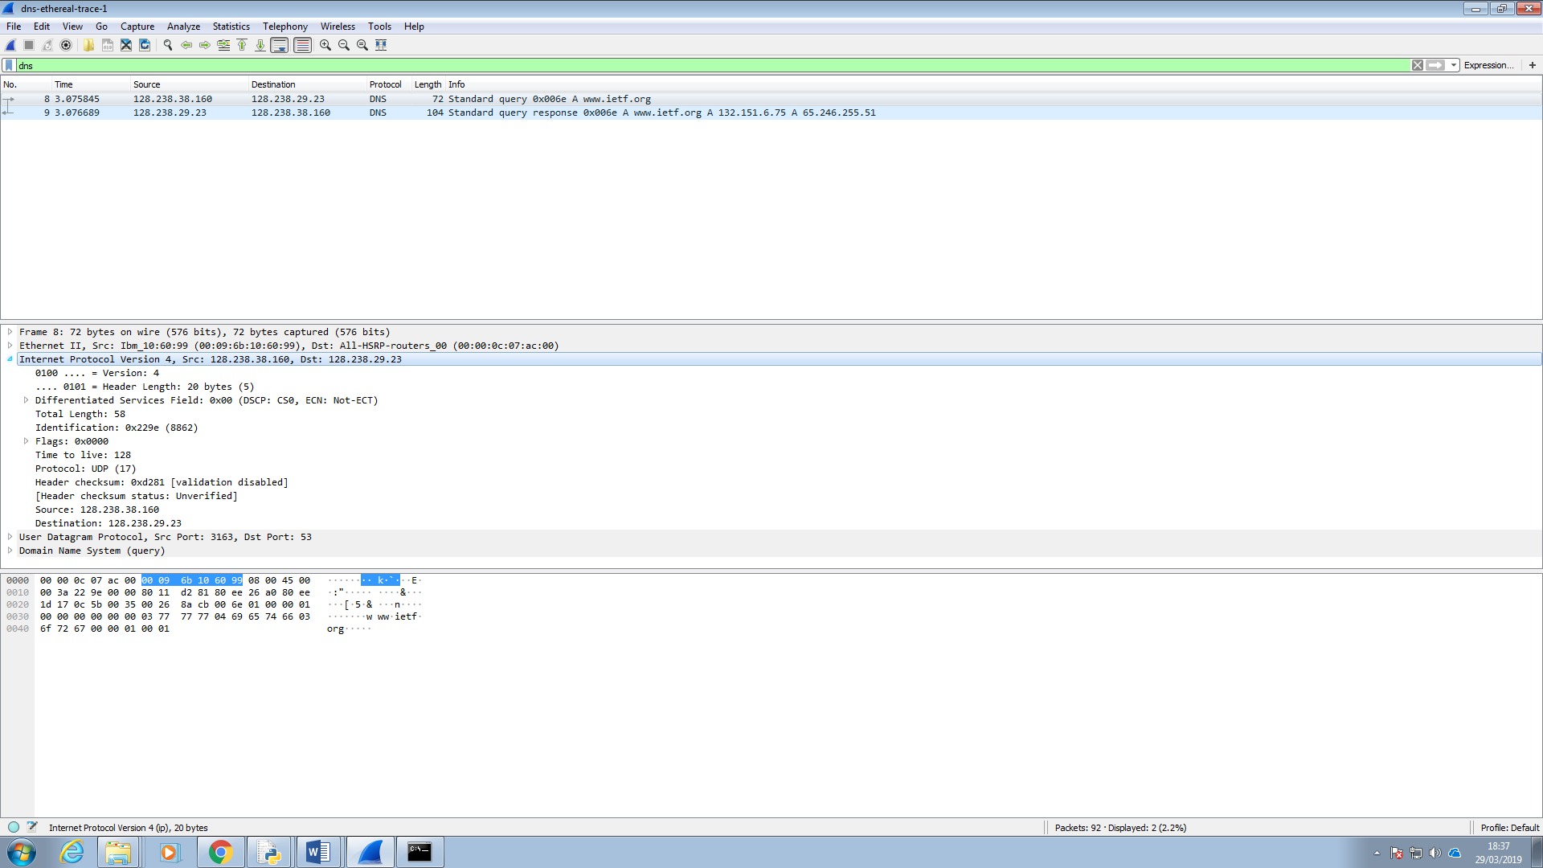

I click on the query response message…

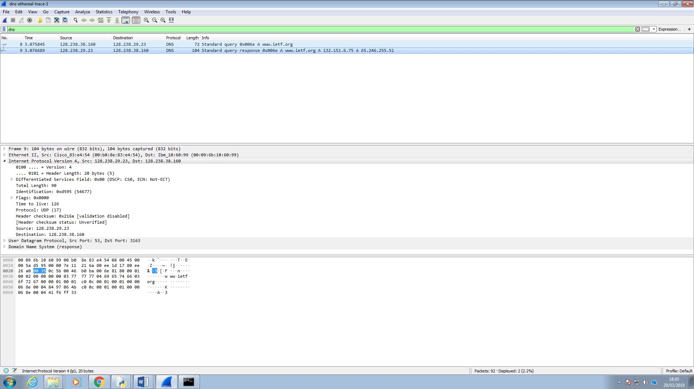

…to get the following details one of which is details of the User Datagram Protocol used to send the messages. The user datagram is sent with the query message from the client to the server.

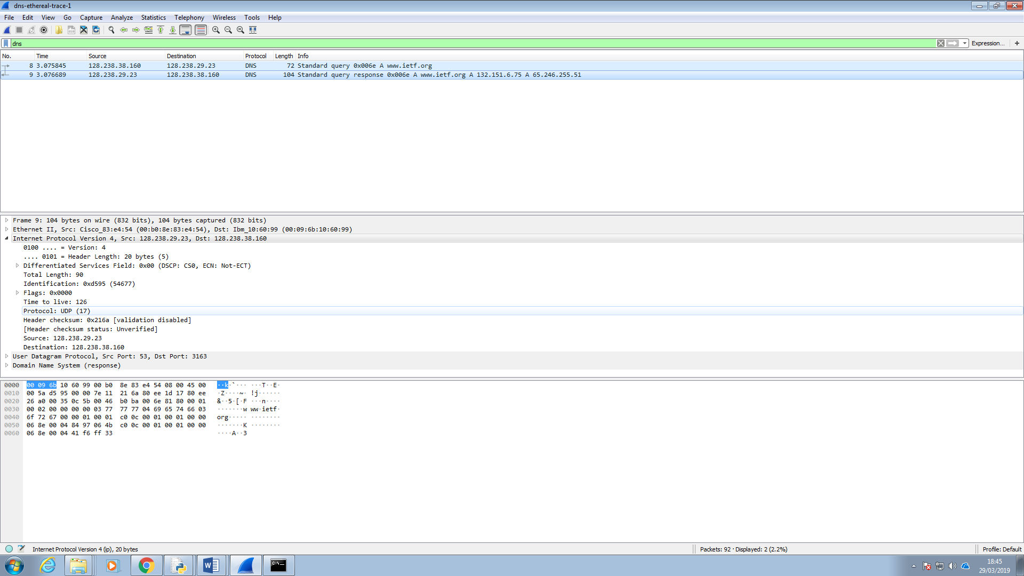

The DNS query and response messages are sent over UDP(which is the user datagram protocol).

5. What is the destination port for the DNS query message? What is the source port of DNS response message?

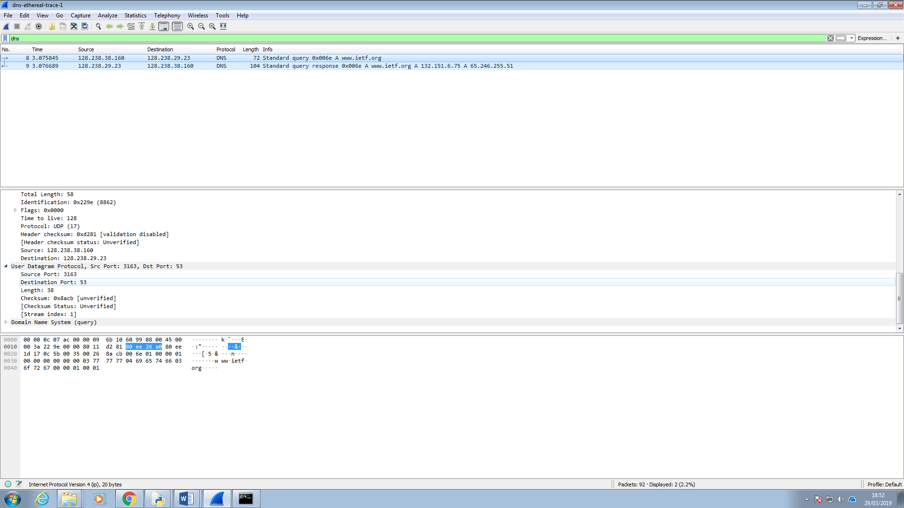

The destination port is 53.

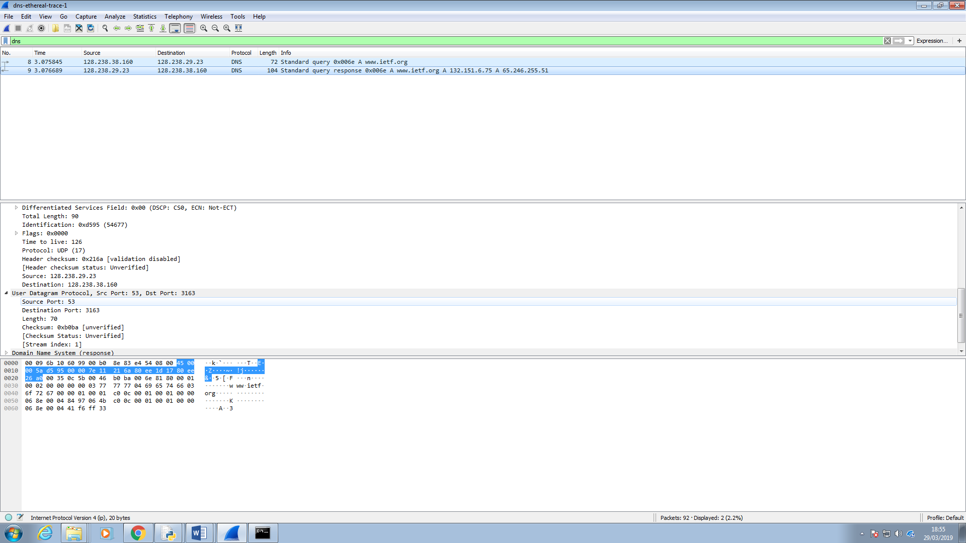



The user datagram was sent back with the response from the server to the client.

The source port of the DNS response message is 53. The destination and source ports are where the messages go through to the client and the server when they are connected to and communicating with each other.

6. To what IP address is the DNS query message sent? Use ipconfig to determine the IP address of your local DNS server. Are these two IP addresses the same?

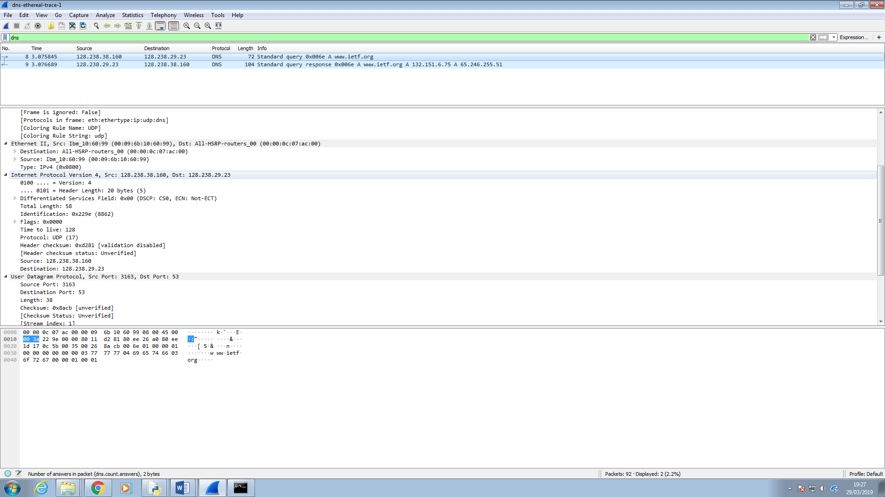

The destination column and the internet protocol details show the destination for the DNS query message as 128.238.29.23.

The IP address the DNS query message is sent to is 128.238.29.23.

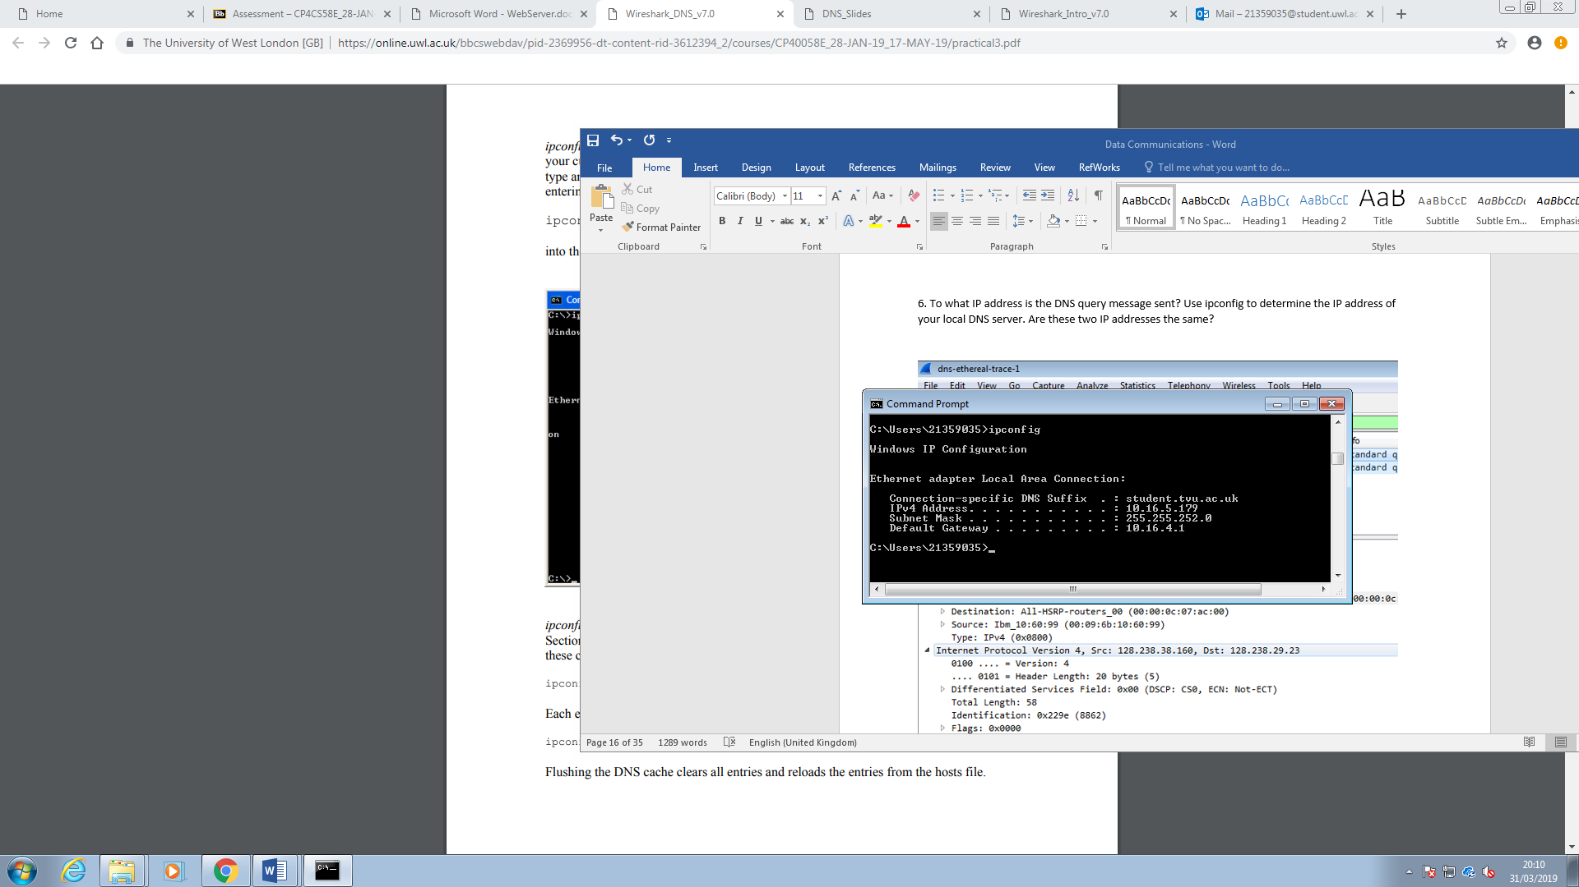

Since this trace file was captured from the computer at a different location to the one I am using this computer the IP address of our local DNS server is different to the one the query message was sent to but it would be the same if I was using the computer at that location. It would be the same IP address if I was running Wireshark on a live network connection.

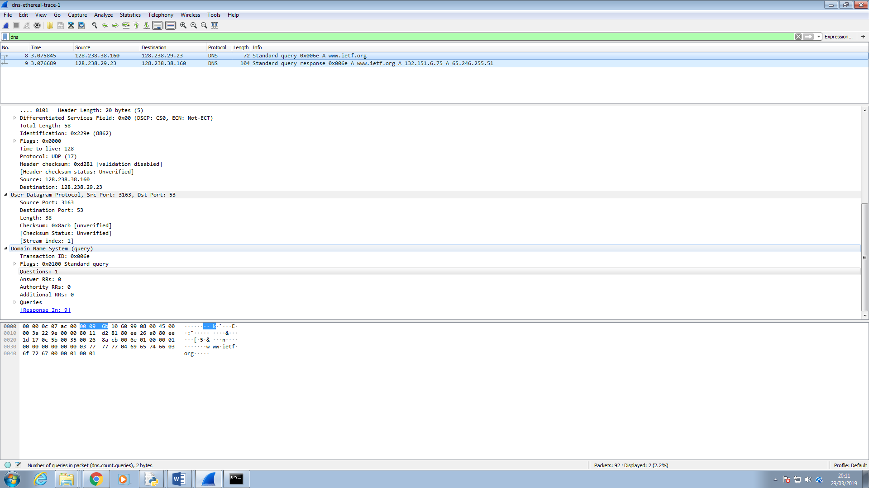

7. Examine the DNS query message. What “Type” of DNS query is it? Does the query message contain any “answers”?

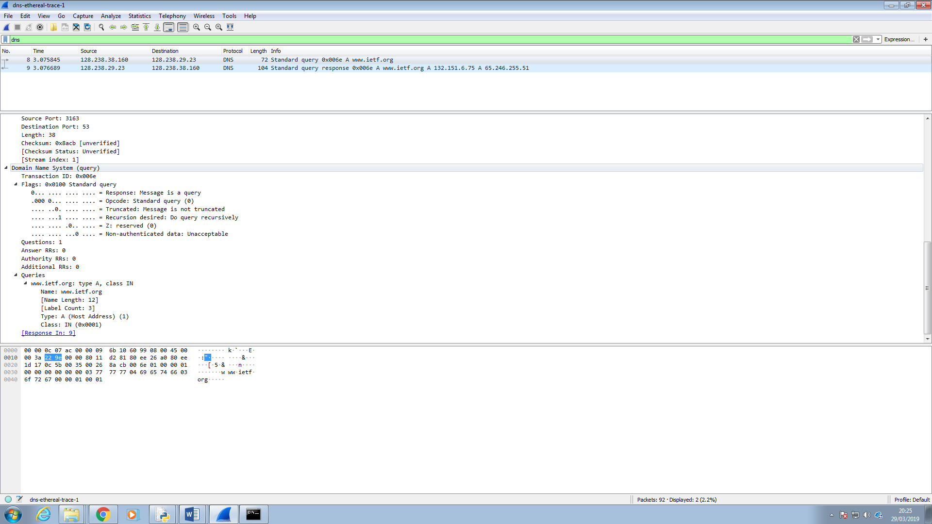

Examining the DNS query it is a type A query. This query is not a query for any name server to include the name of any server and their IP addresses.

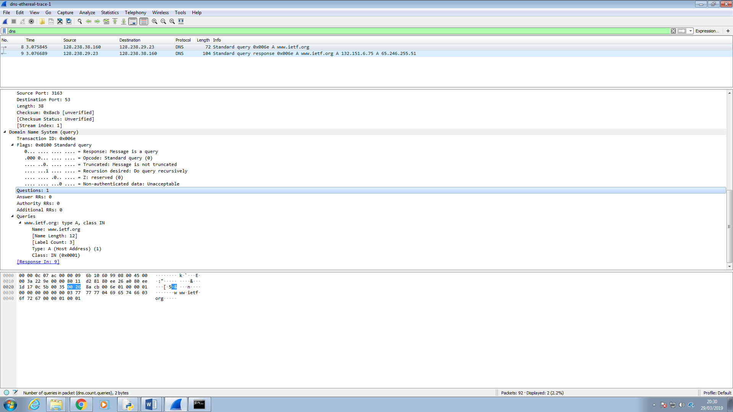

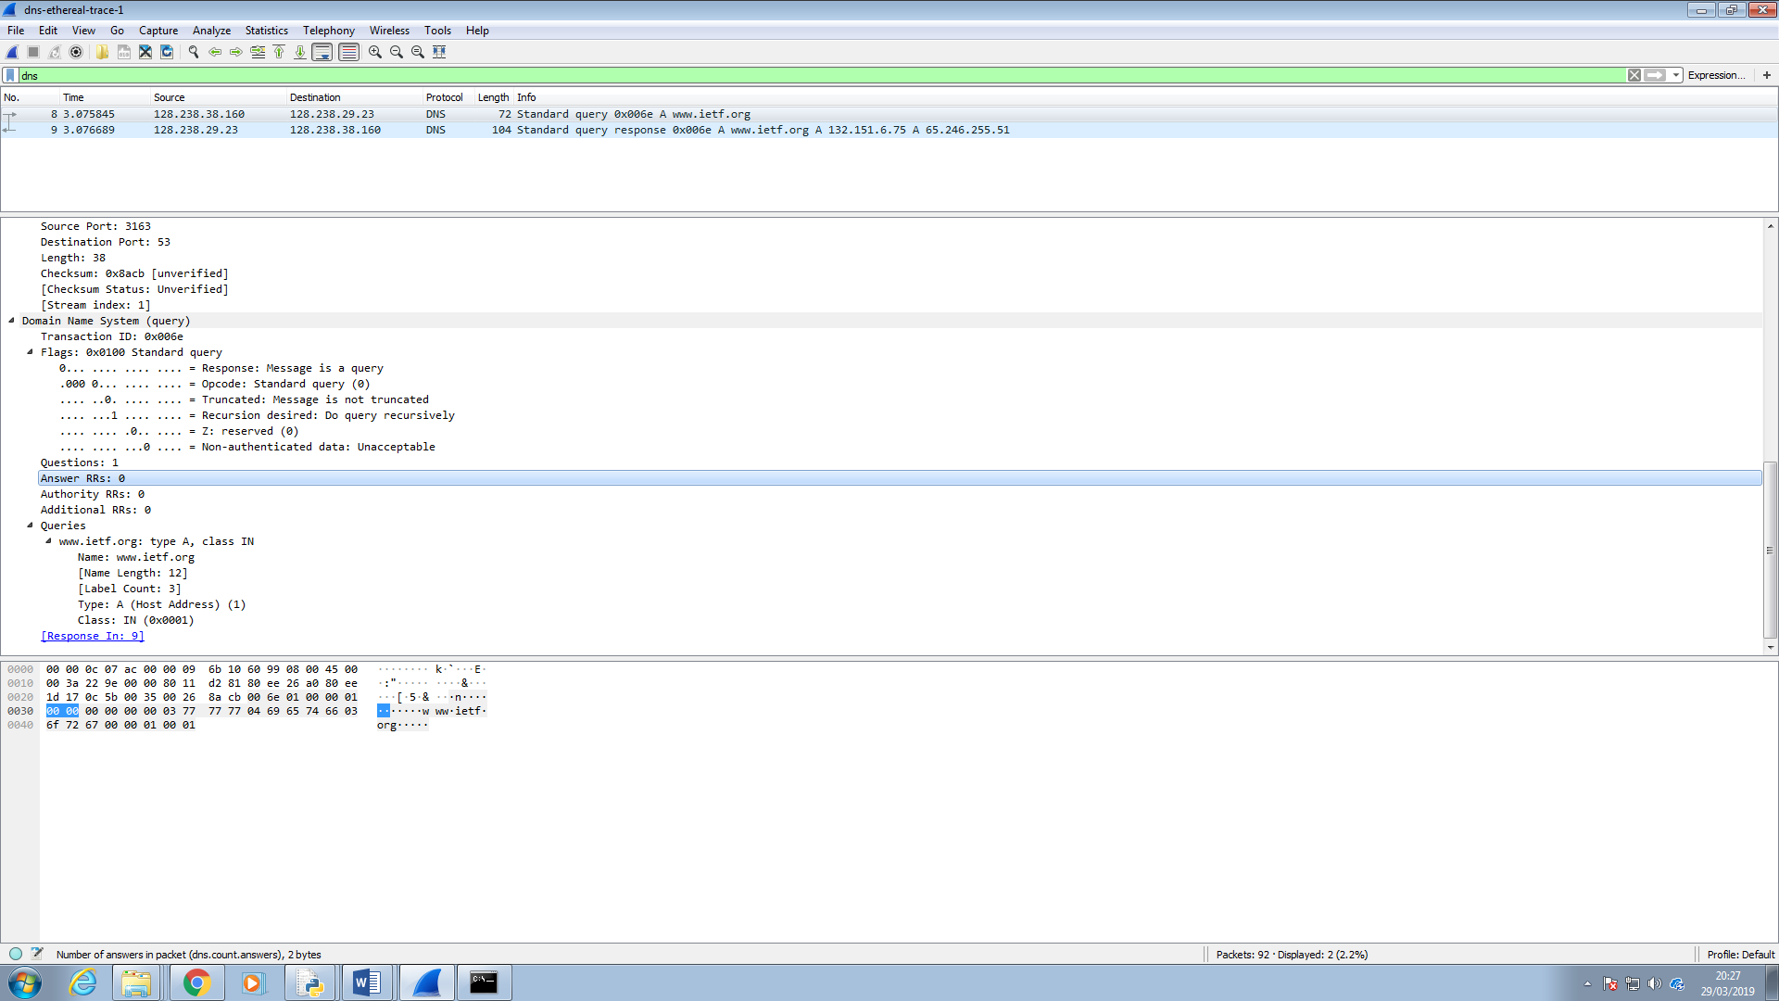

Being a DNS the query is for the web address [www.ietf.org](http://www.ietf.org) and getting its IP. Before the DNS response message is sent back the message does not have any answers.

8. Examine the DNS response message. How many “answers” are provided? What do each of these answers contain?

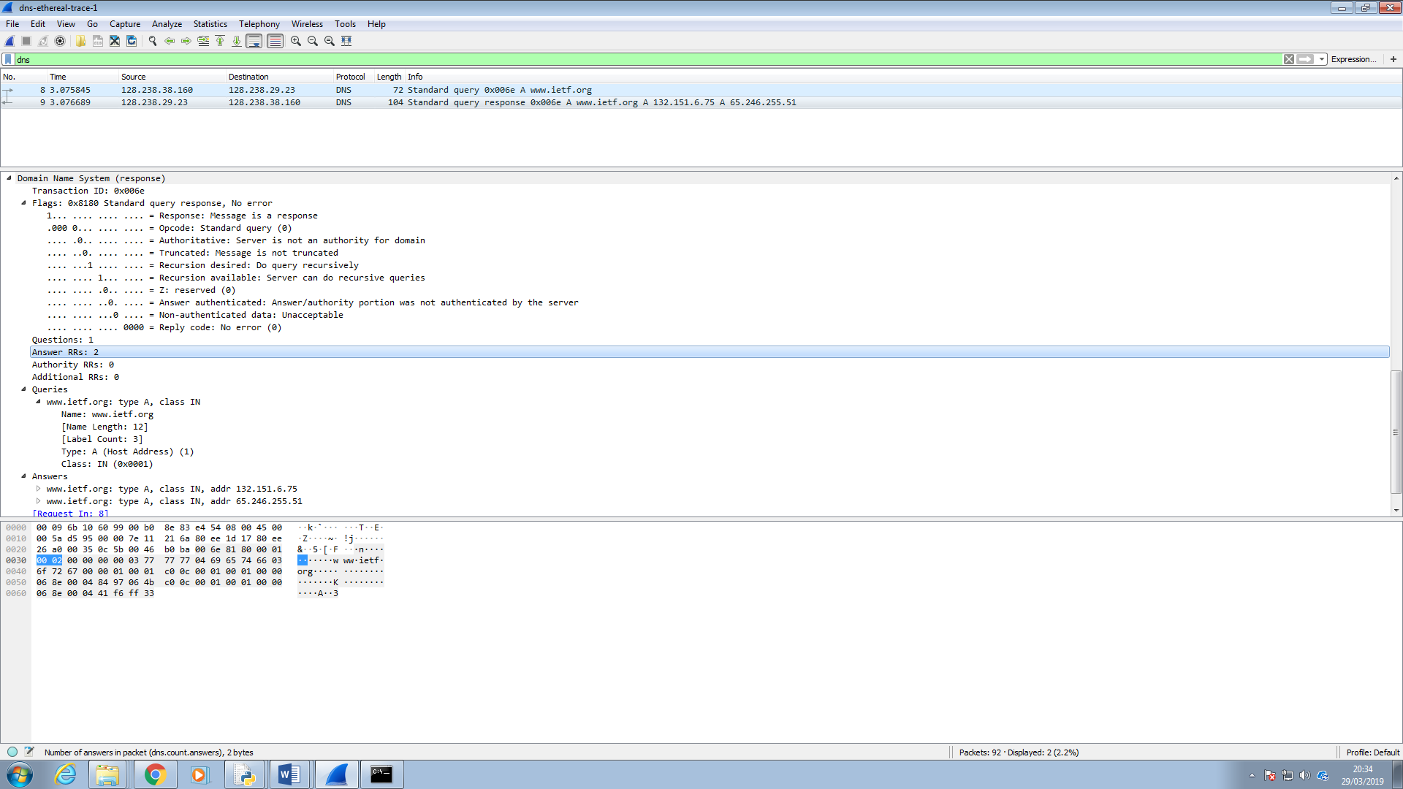

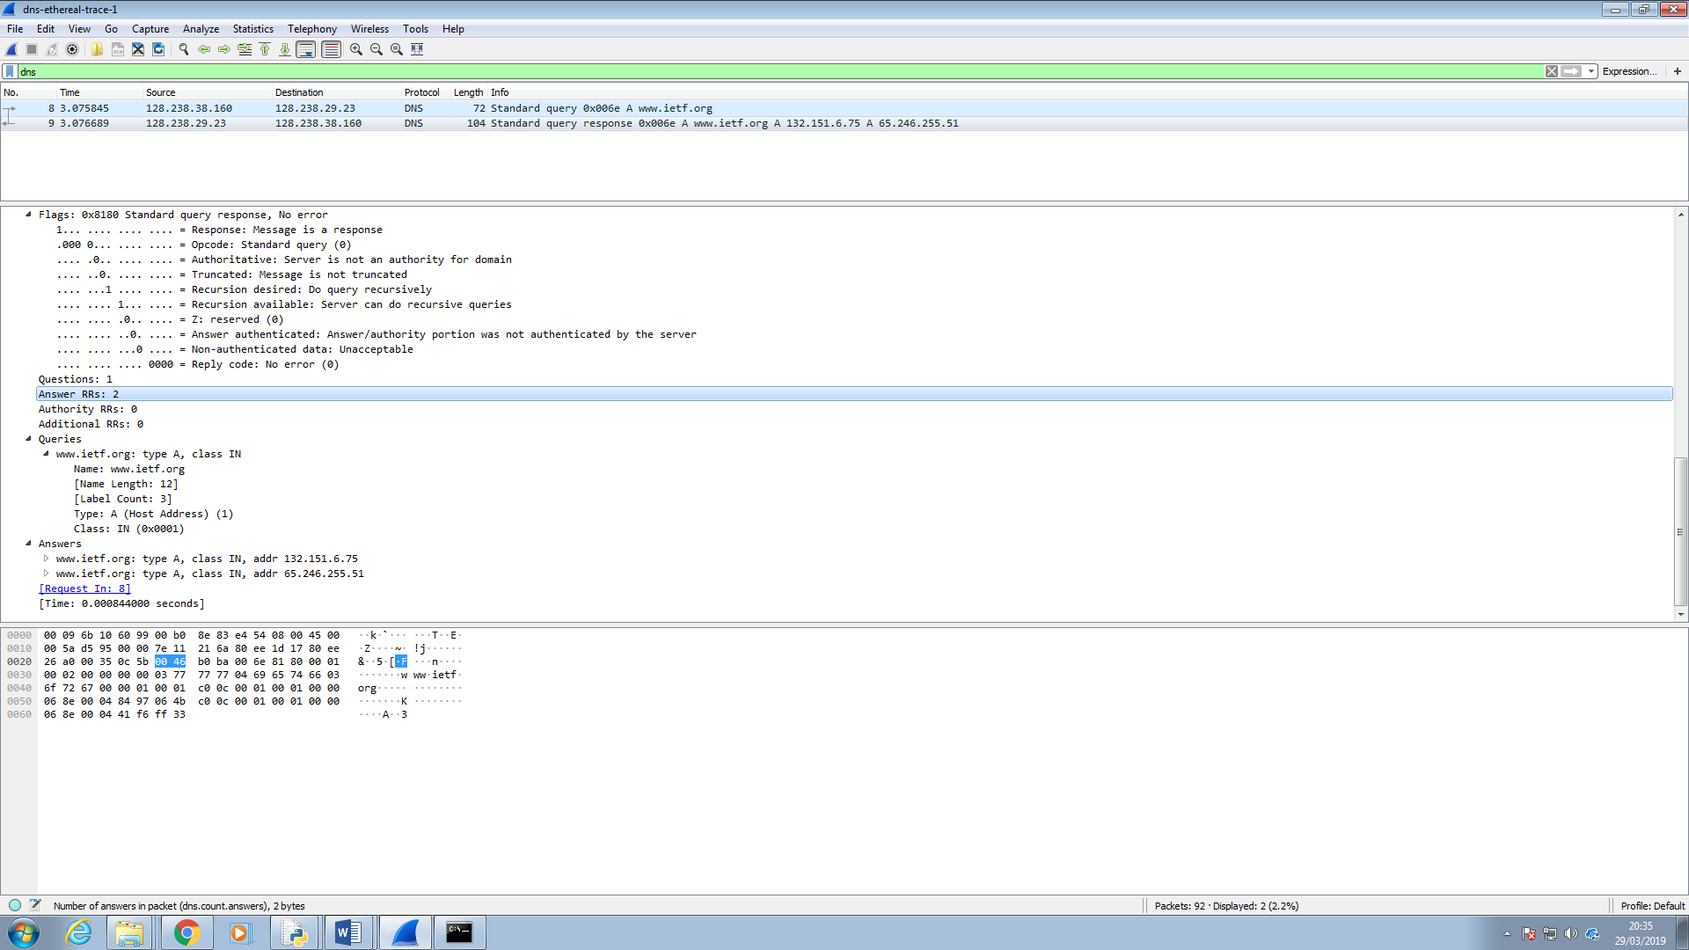

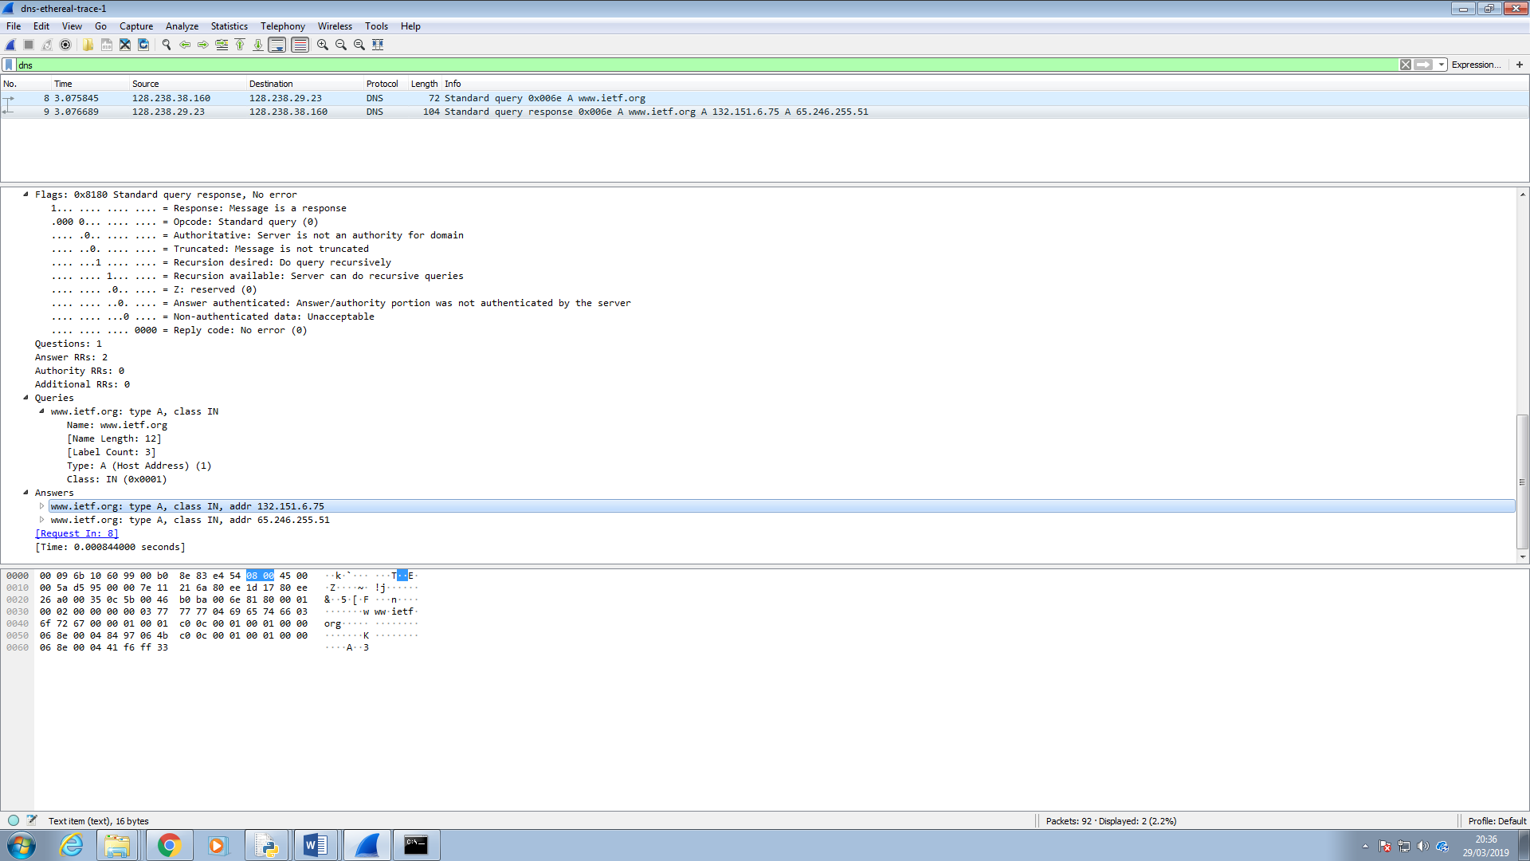

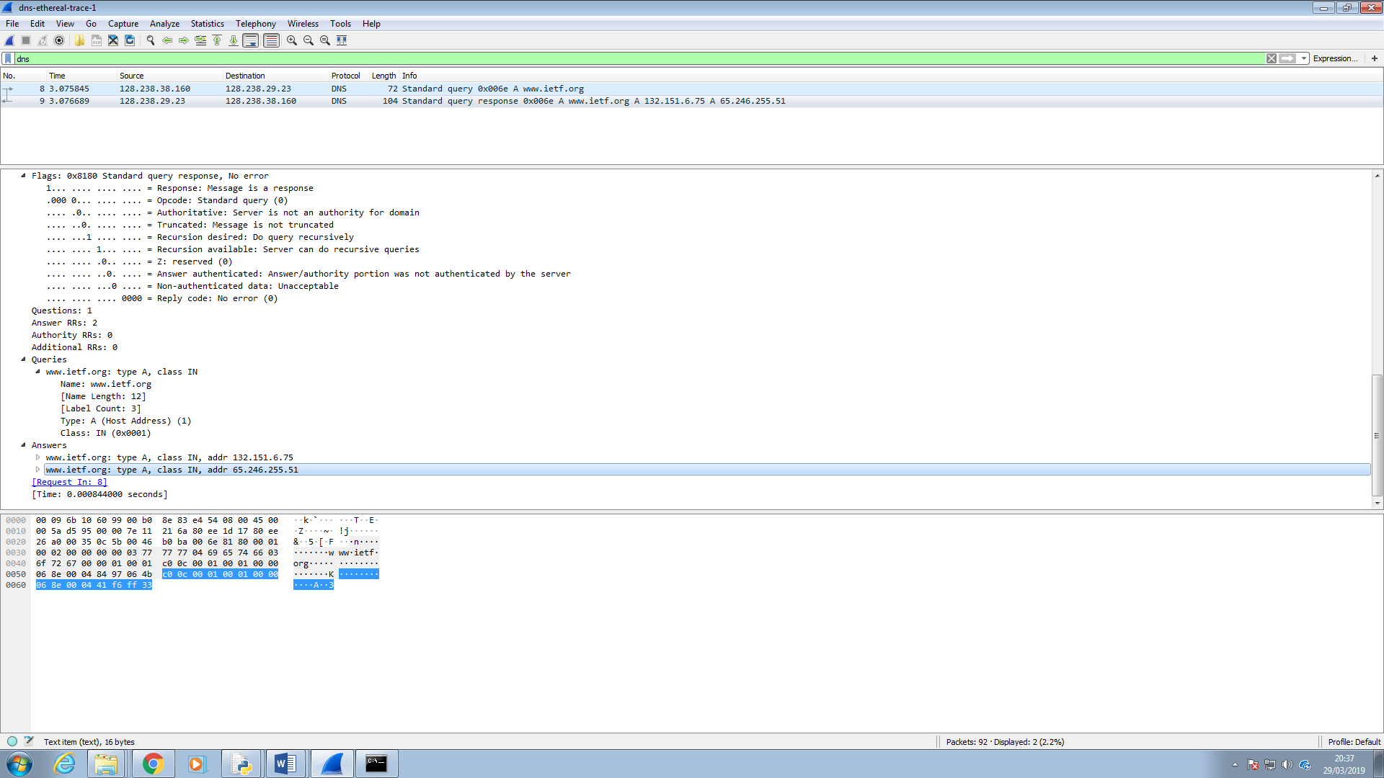

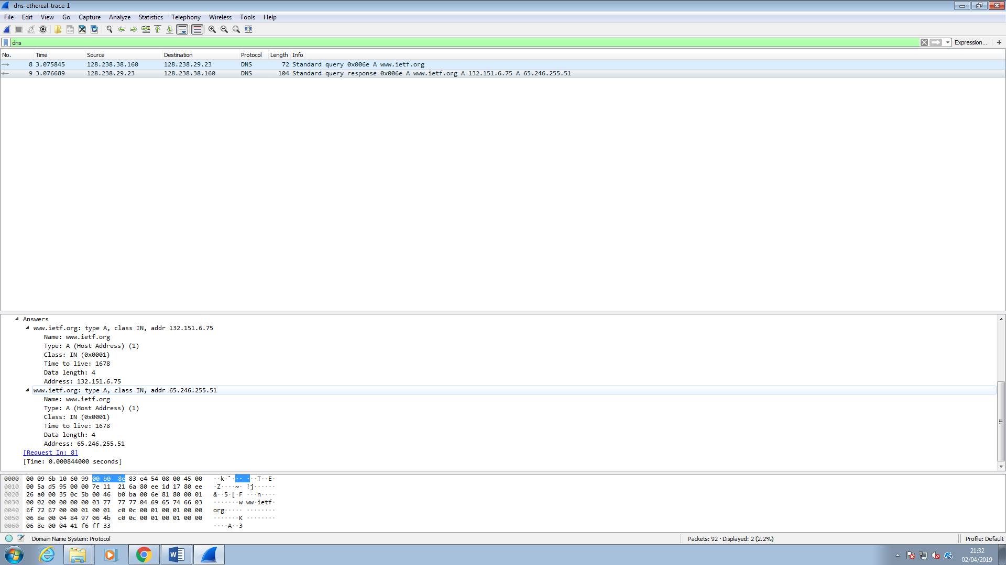

Examining the response message, it is a standard query response as in a response to the query that was sent. It has two answers rather than one. The answers which were sent as the response message each contain the name of the host, an IP address and the type which is A as it is a host address not a query for names and IP addresses of a name server. They also contain the time the message was captured live and the length of the data. The two IP addresses sent as a response were provided using other protocols like HTTP and TCP since they are not the same as the addresses in the DNS query and response messages.

9. Consider the subsequent TCP SYN packet sent by your host. Does the destination IP address of the SYN packet correspond to any of the IP addresses provided in the DNS response message?

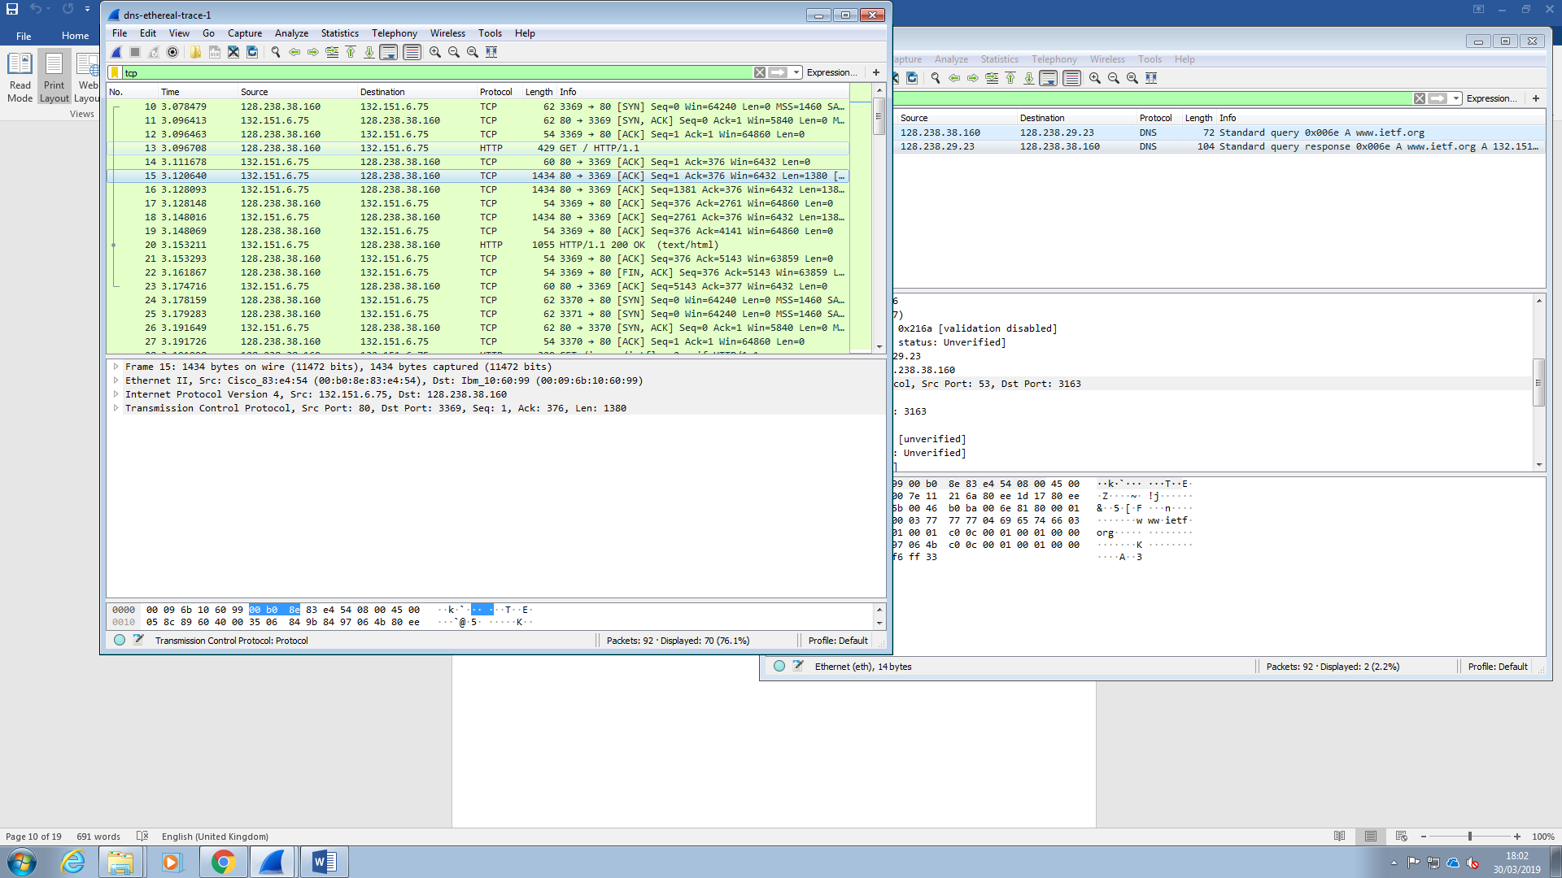

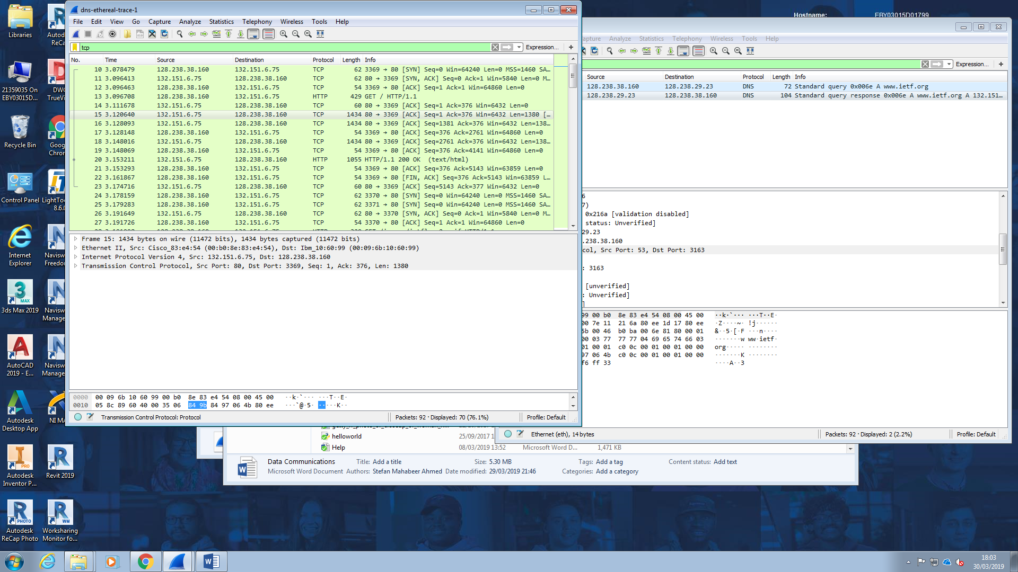

Considering the TCP SYN packet sent by the host here which means has been sent to and back in a sequence using a sequence number as shown in the info column. The protocols used for this are the TCP (Transfer Control Protocol) and HTTP (Hyper Text Transfer Protocol).

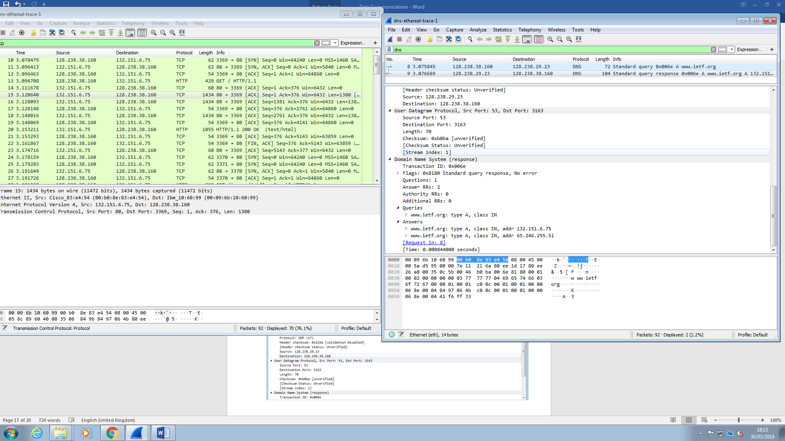

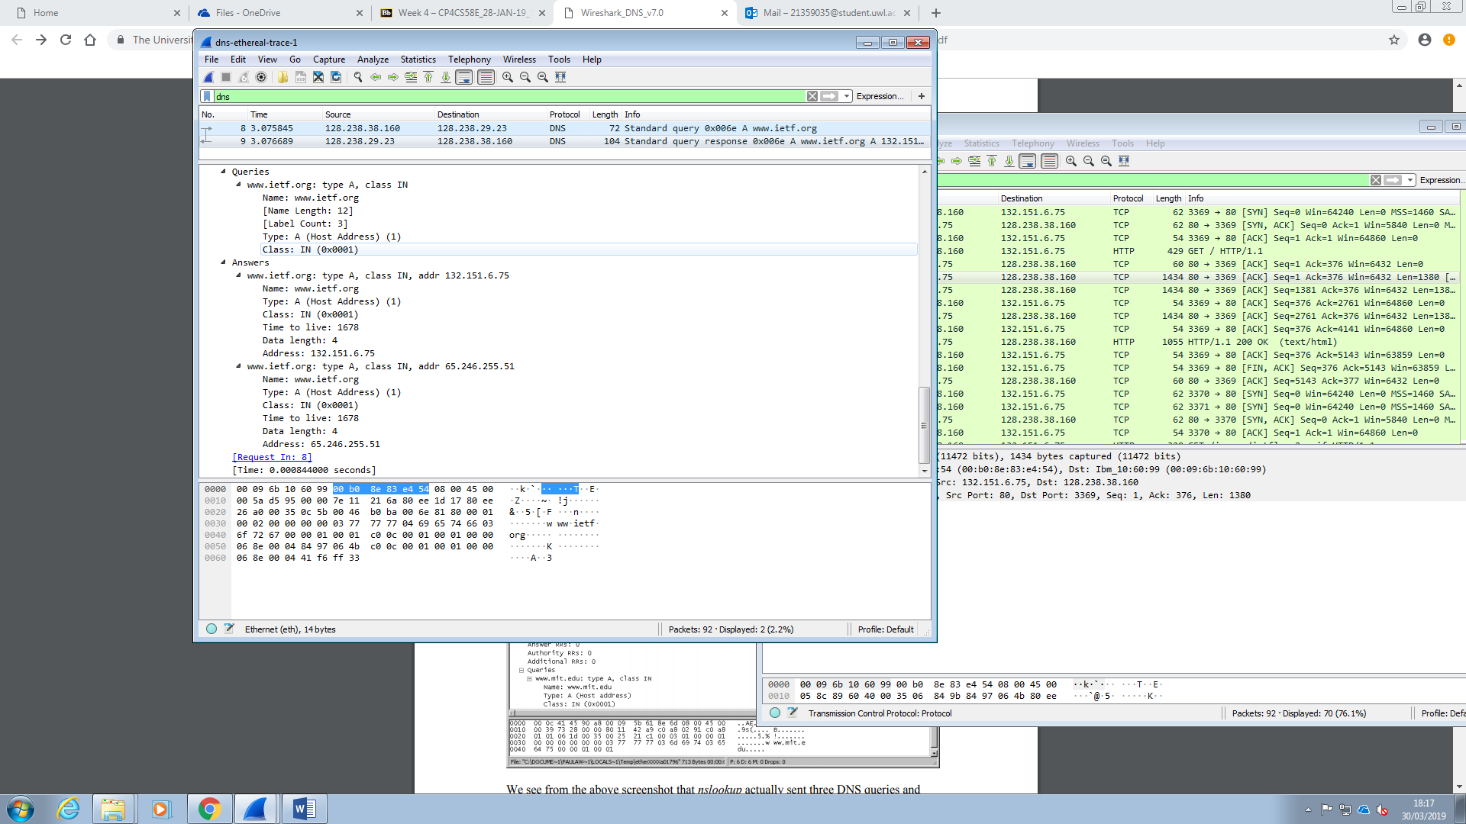



The destination IP address of the first SYN packet sent which is 132.151.6.75 is the same IP address, provided in the DNS response message, of the name server for the webpage address [www.ietf.org](http://www.ietf.org): type A, class IN, shown above.

10. This web page contains images. Before retrieving each image, does your host issue new DNS queries?

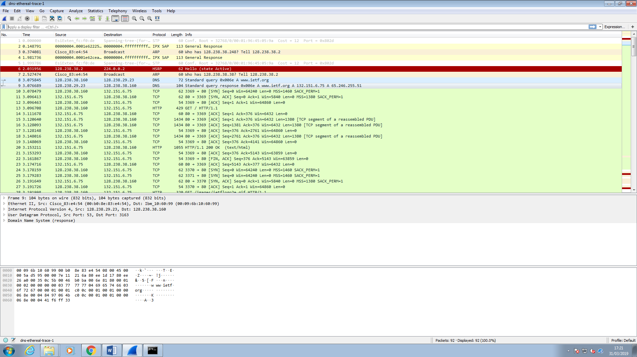

The DNS query and response messages are listed above the messages that use the TCP and HTTP protocols to get the images. So yes the host does issue new DNS queries before retrieving each image.

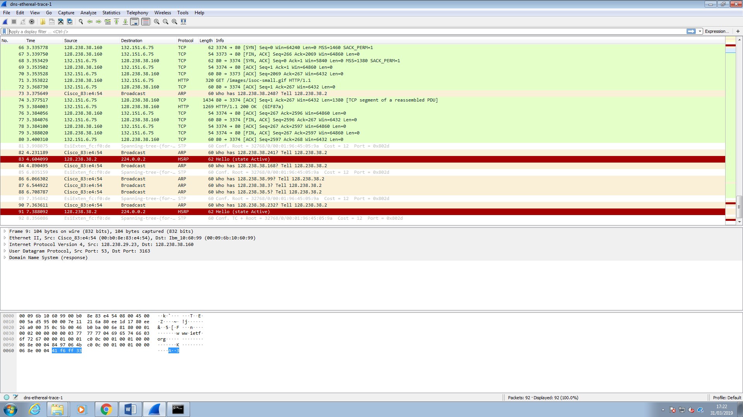

You can also see above the word get in capitals, under the Info column, which is the method used to get an image loaded onto the webpage.

Now I play with nslookup:

Doing an nslookup on www.mit.edu

11. What is the destination port for the DNS query message? What is the source port of DNS response message?

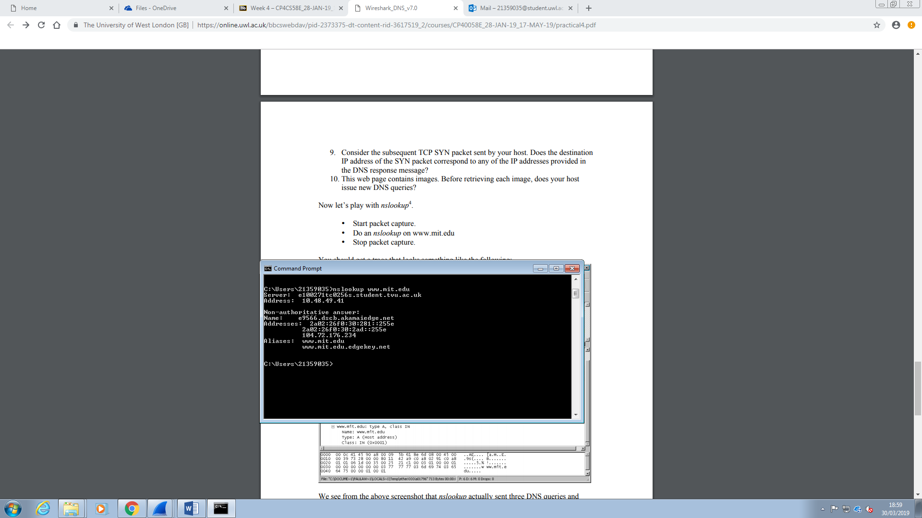

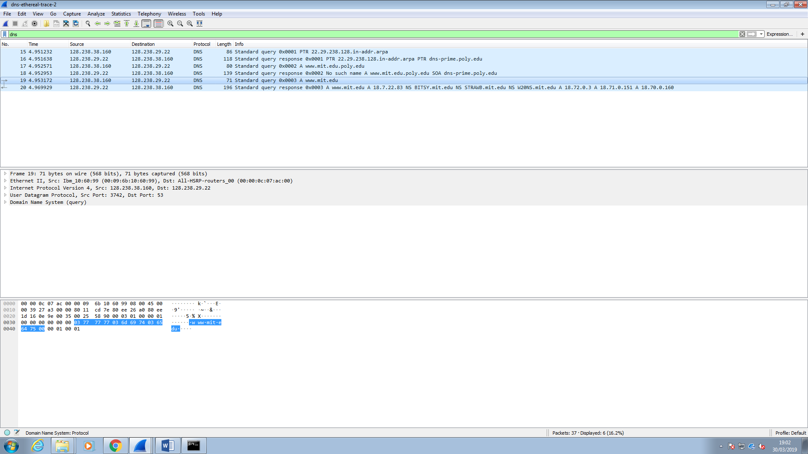

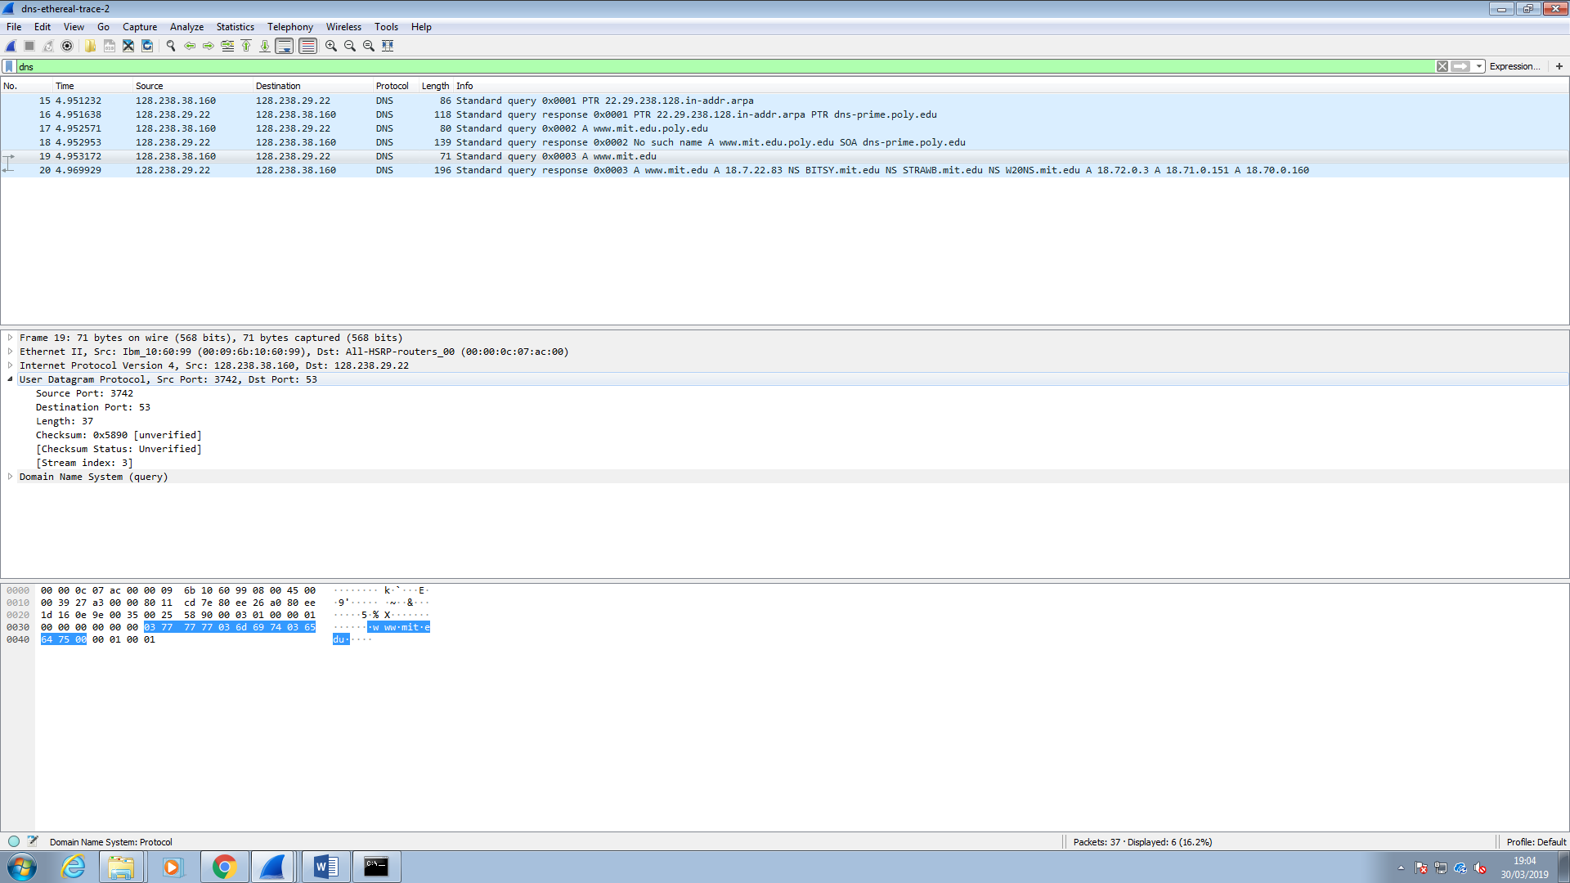

The destination port for the query message is 53.

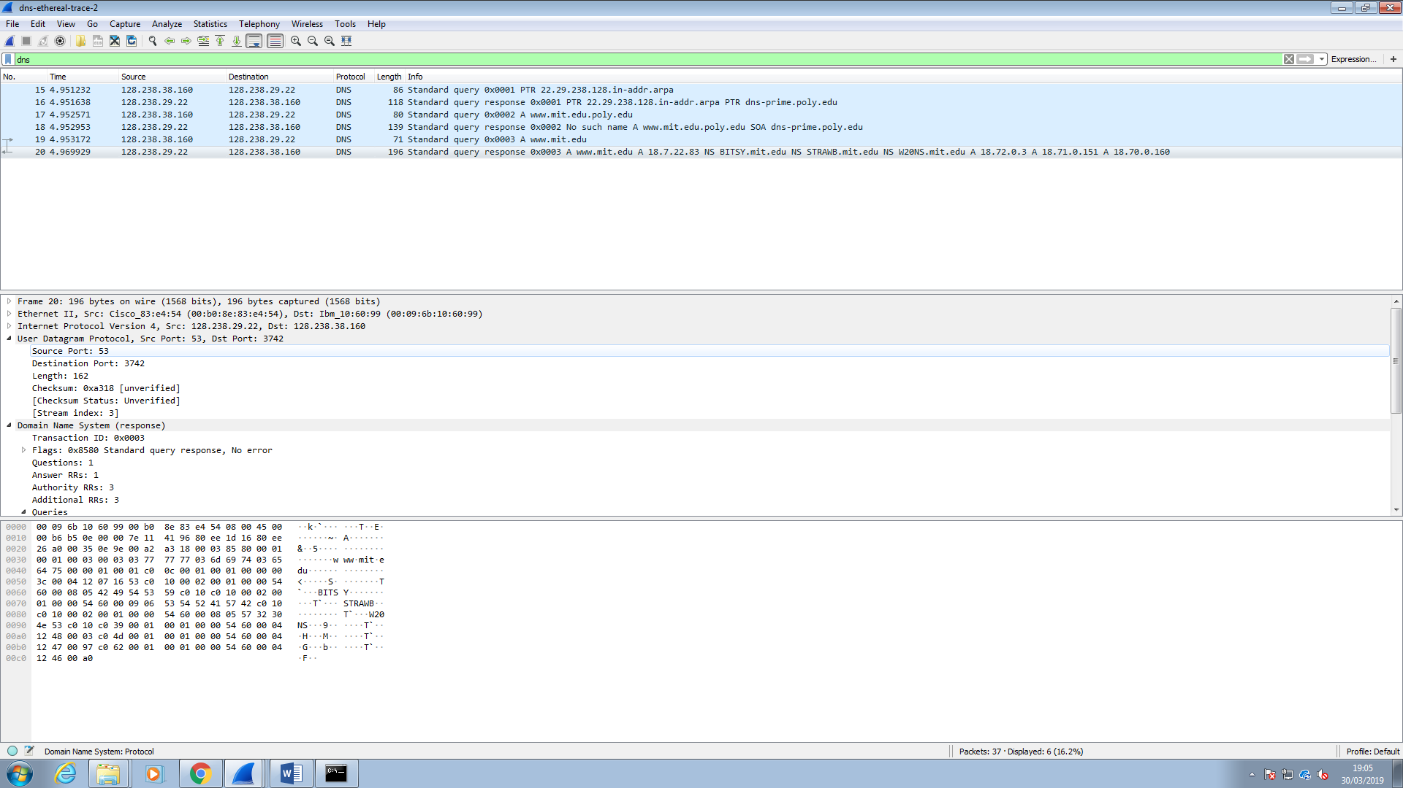

The source port for the response message is 53.

12. To what IP address is the DNS query message sent? Is this the IP address of your default local DNS server?

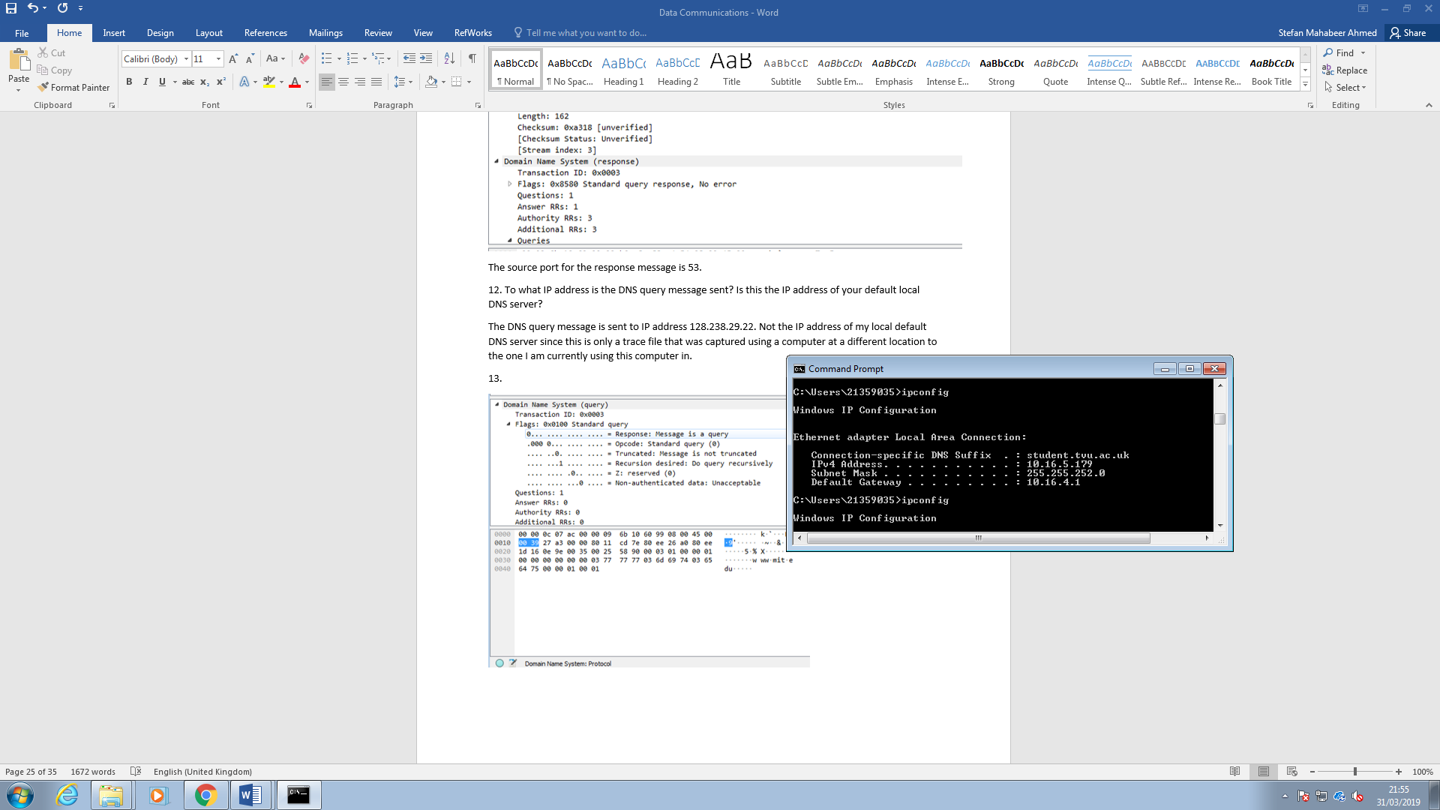

The DNS query message is sent to IP address 128.238.29.22. Not the IP address of my local default DNS server since this is only a trace file that was captured using a computer at a different location to the one I am currently using this computer in.

13. Examine the DNS query message. What “Type” of DNS query is it? Does the query message contain any “answers”?

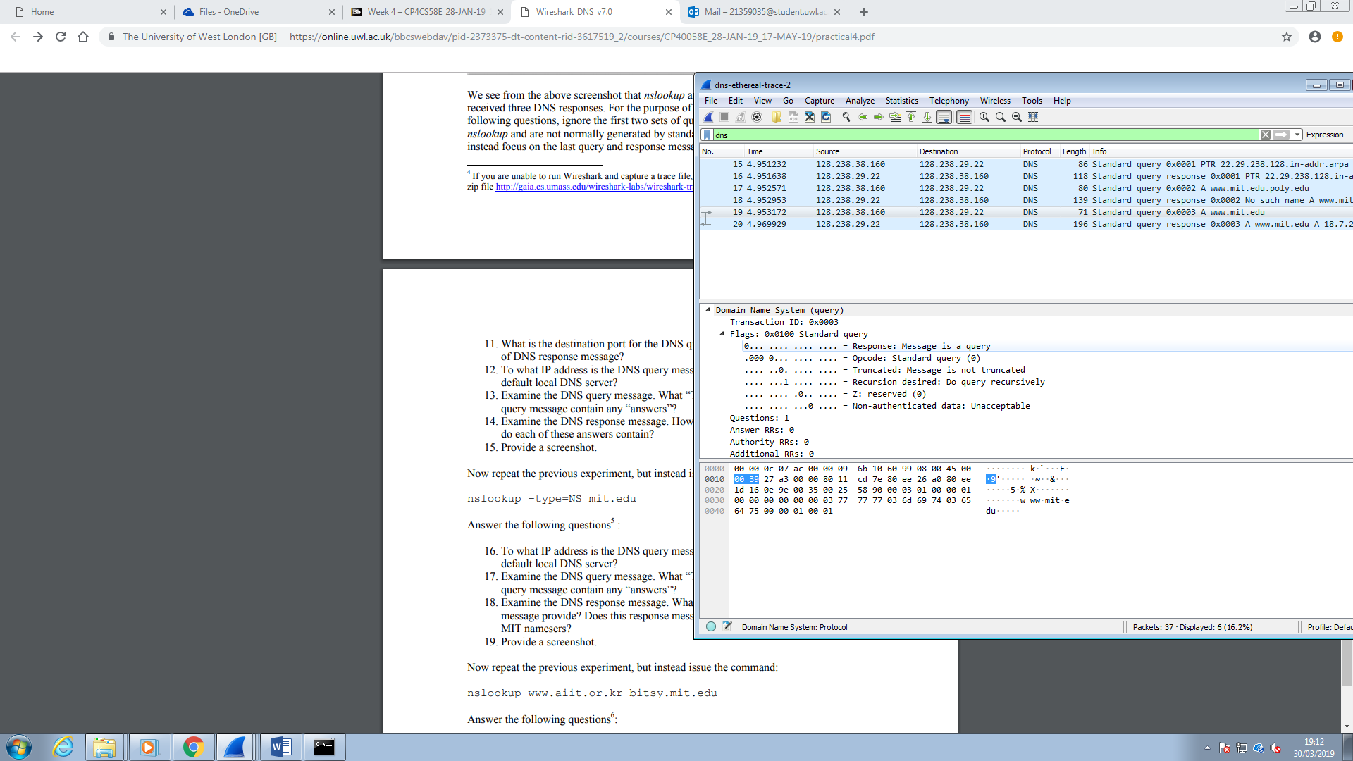

It is a standard type AAA query. It has no answers since it is the query before the response message is sent.

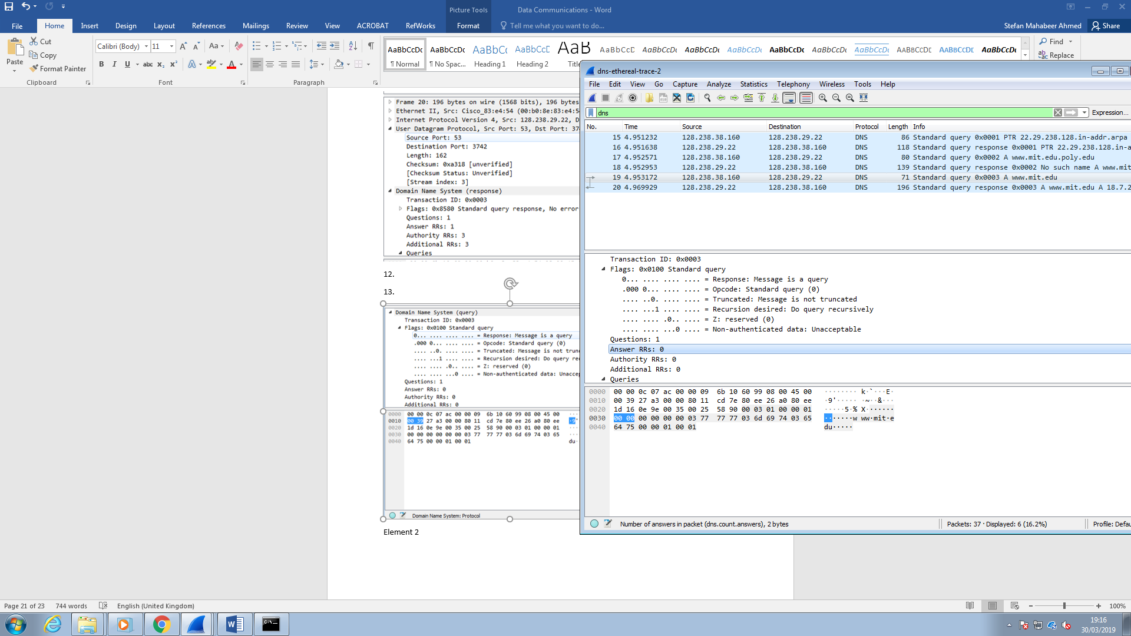

Shown above are details of the packet in hexadecimal and ASCII. No answers mean zeroes are shown.

14. Examine the DNS response message. How many “answers” are provided? What do each of these answers contain?

One answer is provided. It contains details of the name server for [www.mit.edu](http://www.mit.edu). This includes (which I forgot to show) the name of the website, time taken to capture the packet during the live capture and the data length.

15. Screenshots

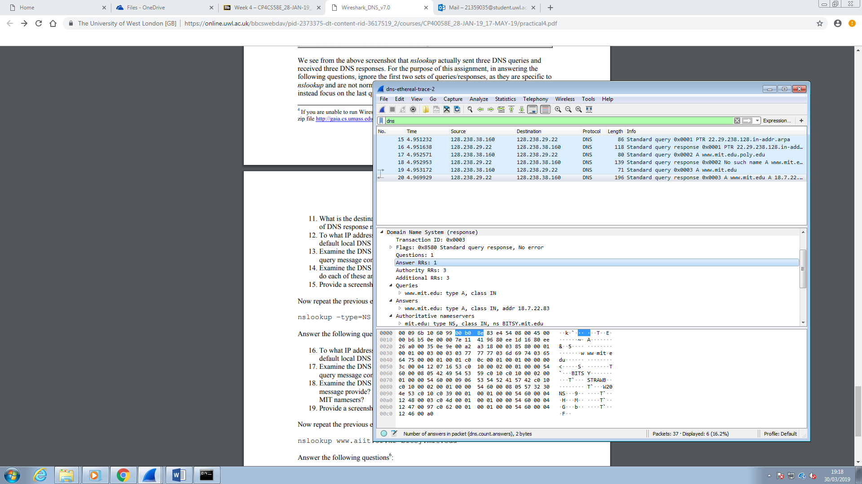

I now run this command:

nslookup –type=NS mit.edu

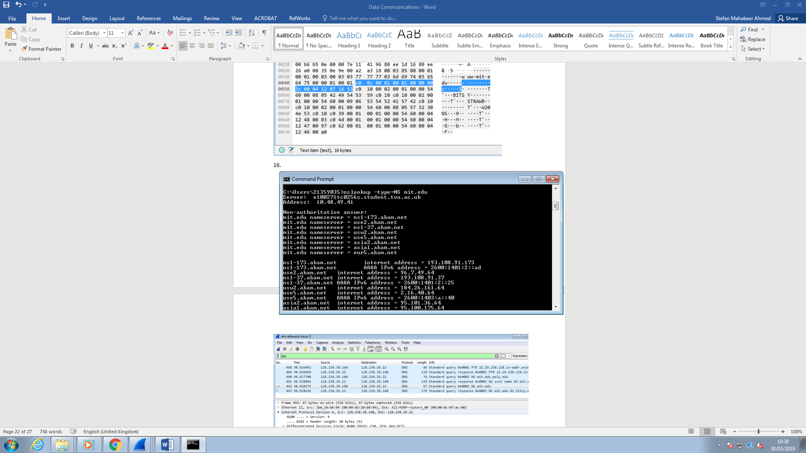

16. To what IP address is the DNS query message sent? Is this the IP address of your default local DNS server?

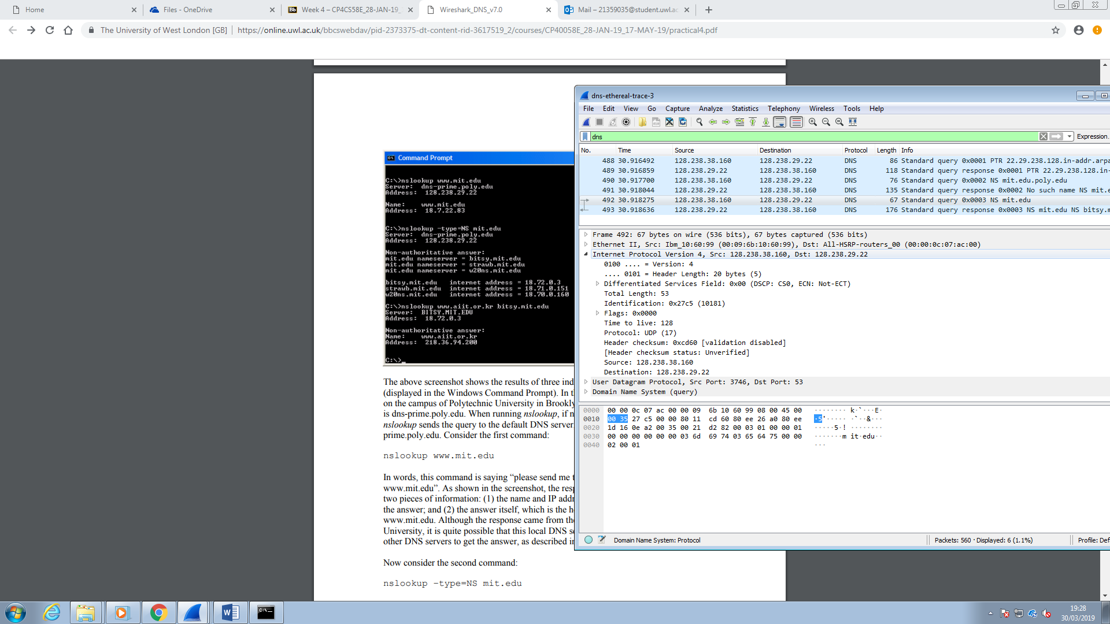

It is sent to IP address 128.238.29.22. Not the IP address of my default local DNS server for the same reasons as mentioned in answer to question 6 and 12.

17. Examine the DNS query message. What “Type” of DNS query is it? Does the query message contain any “answers”?

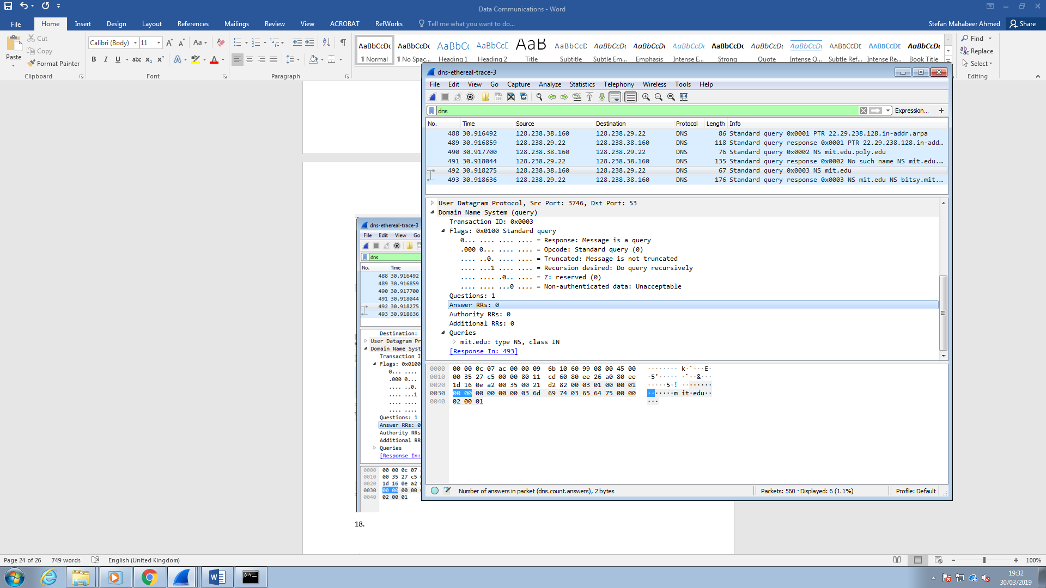

The type of DNS query is an NS type (query sent to the server for records of name servers), with no answers.

18. Examine the DNS response message. What MIT nameservers does the response message provide? Does this response message also provide the IP addresses of the MIT nameservers?

It provides nameservers bitsy.mit.edu(address 18.72.0.3), strawb.mit.edu(address 18.71.0.151) and w20ns.mit.edu(address 18.70.0.160). This response message provides the IP addresses of the MIT name servers as a list of additional records.

19.Screenshot provided below

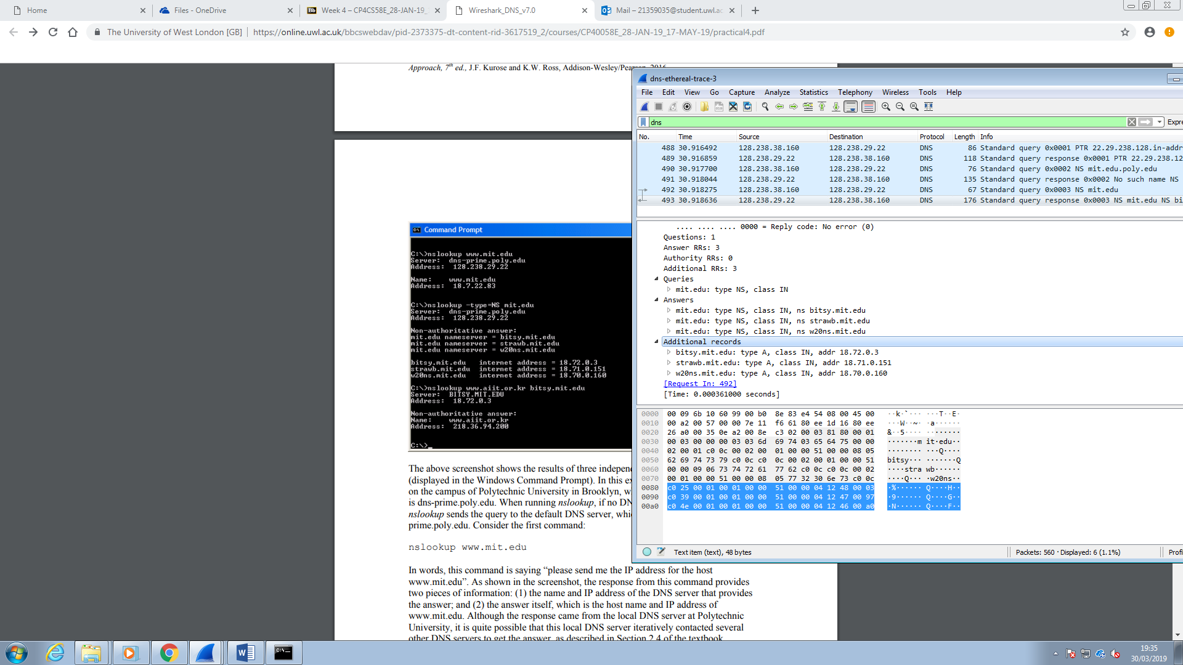

I repeat the previous experiment but with this command:

nslookup www.aiit.or.kr bitsy.mit.edu

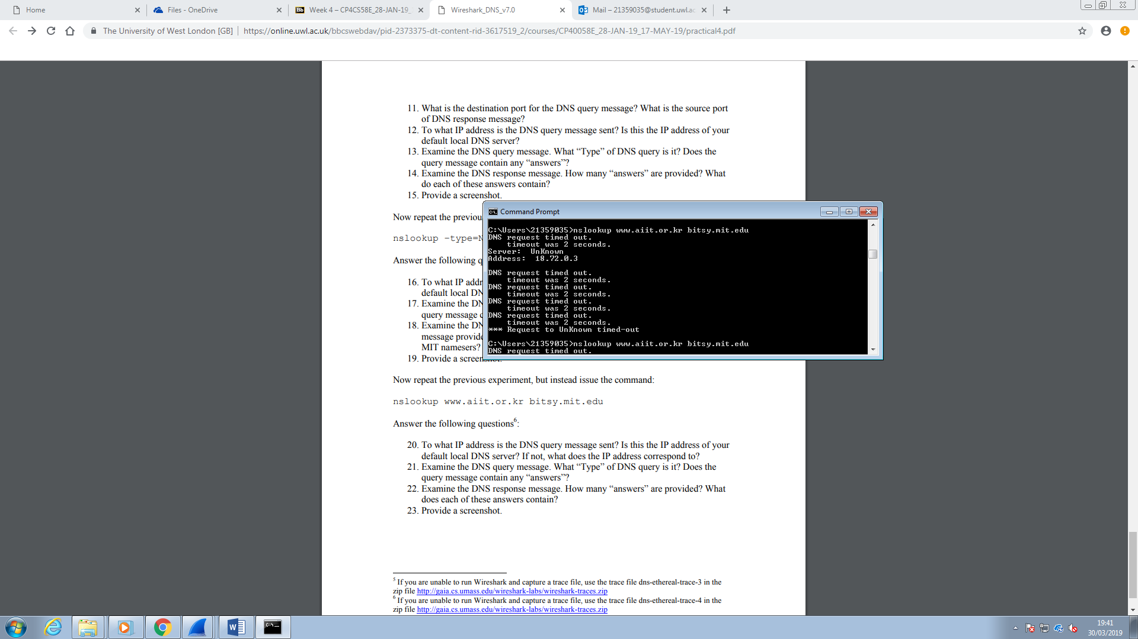

20. To what IP address is the DNS query message sent? Is this the IP address of your default local DNS server? If not, what does the IP address correspond to?

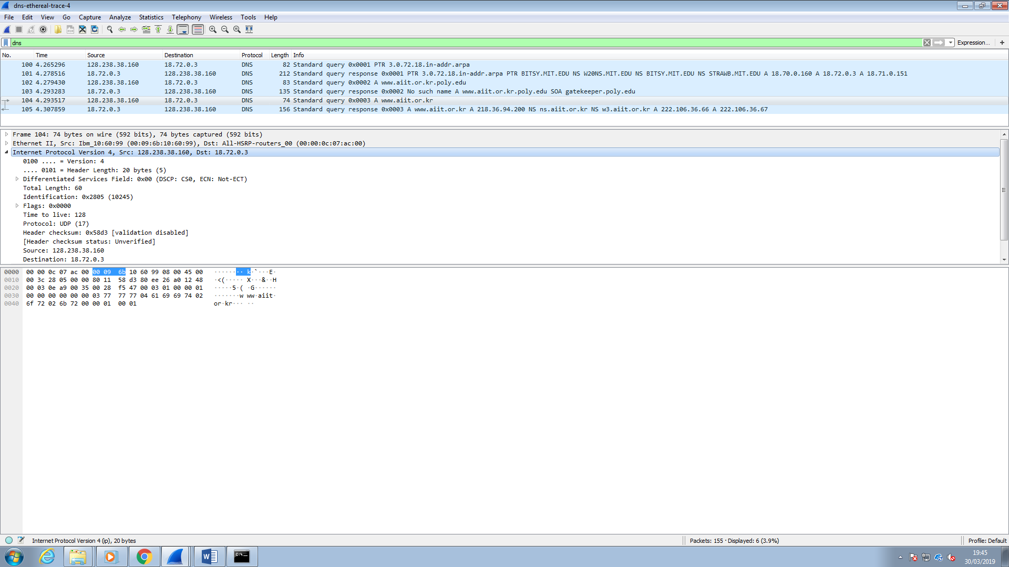

The DNS query message is sent to IP address 18.72.0.3. This is not the IP address of my local default DNS server. It is the same as name server at mit.edu which is bitsy.mit.edu.

21. Examine the DNS query message. What “Type” of DNS query is it? Does the query message contain any “answers”?

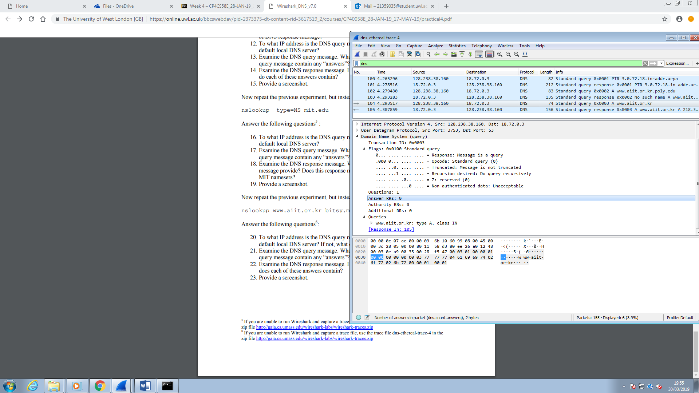

It is a type A query. It does not contain any answers.

22. Examine the DNS response messages. How many “answers” are provided? What does each of these answers contain?

One answer is provided which contains the details of the host including server name, address, the type, the time taken to capture it live and the length of the data.

23. Screenshot

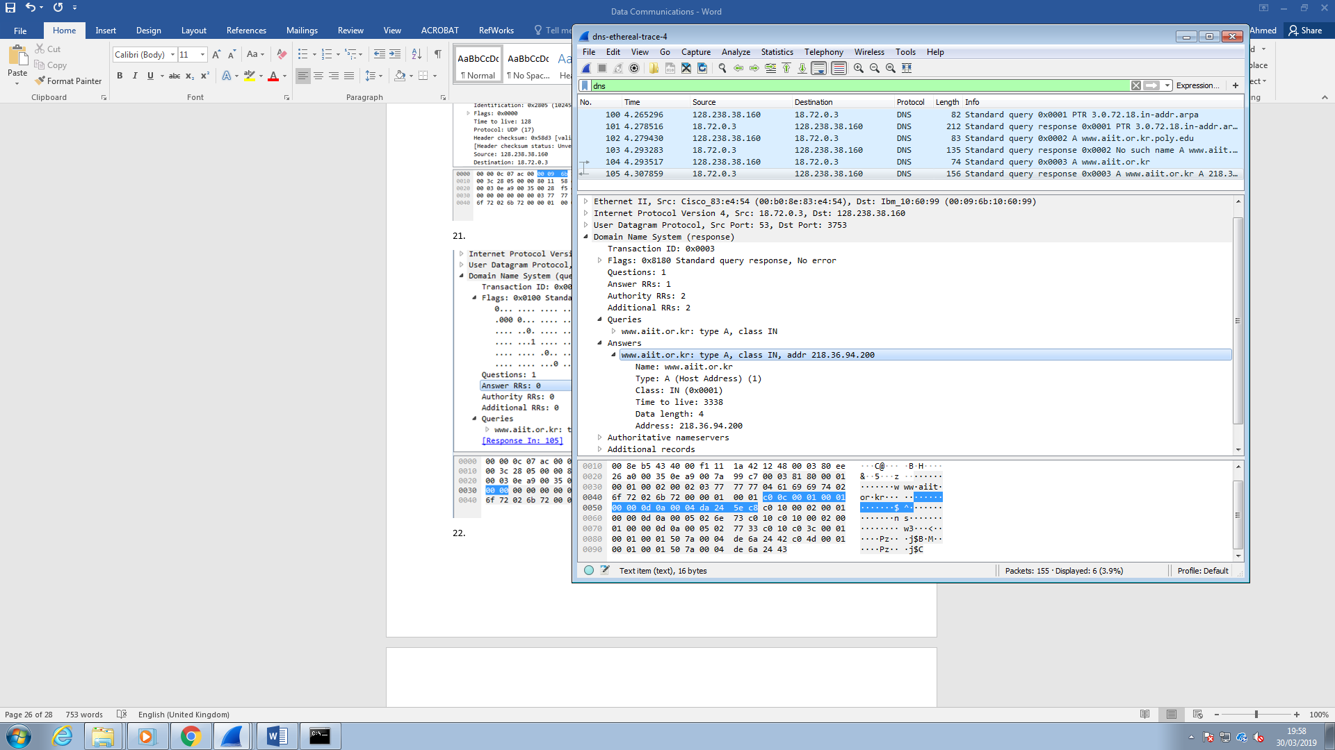

Element 2

This second part of this assignment focuses on communication between the server and the client. A network is devices connected to each other such as the computer connected to a server to request a webpage from it. The server is the computer which holds a live copy of the webpage and the client is the computer that has requested a copy of the webpage from the server. When the client requests the webpage from the server, the server receives the request and then sends the page to the client.

I am going to test the connection between the server and the client by creating a webpage using language known as html and store that file in the same folder as the code for the web server written using programming code in a language known as Python. I have to store them both in the same folder in order for them to connect to each other. So the web browser that will load webpage is the client and the web server file written in programming language is the server.

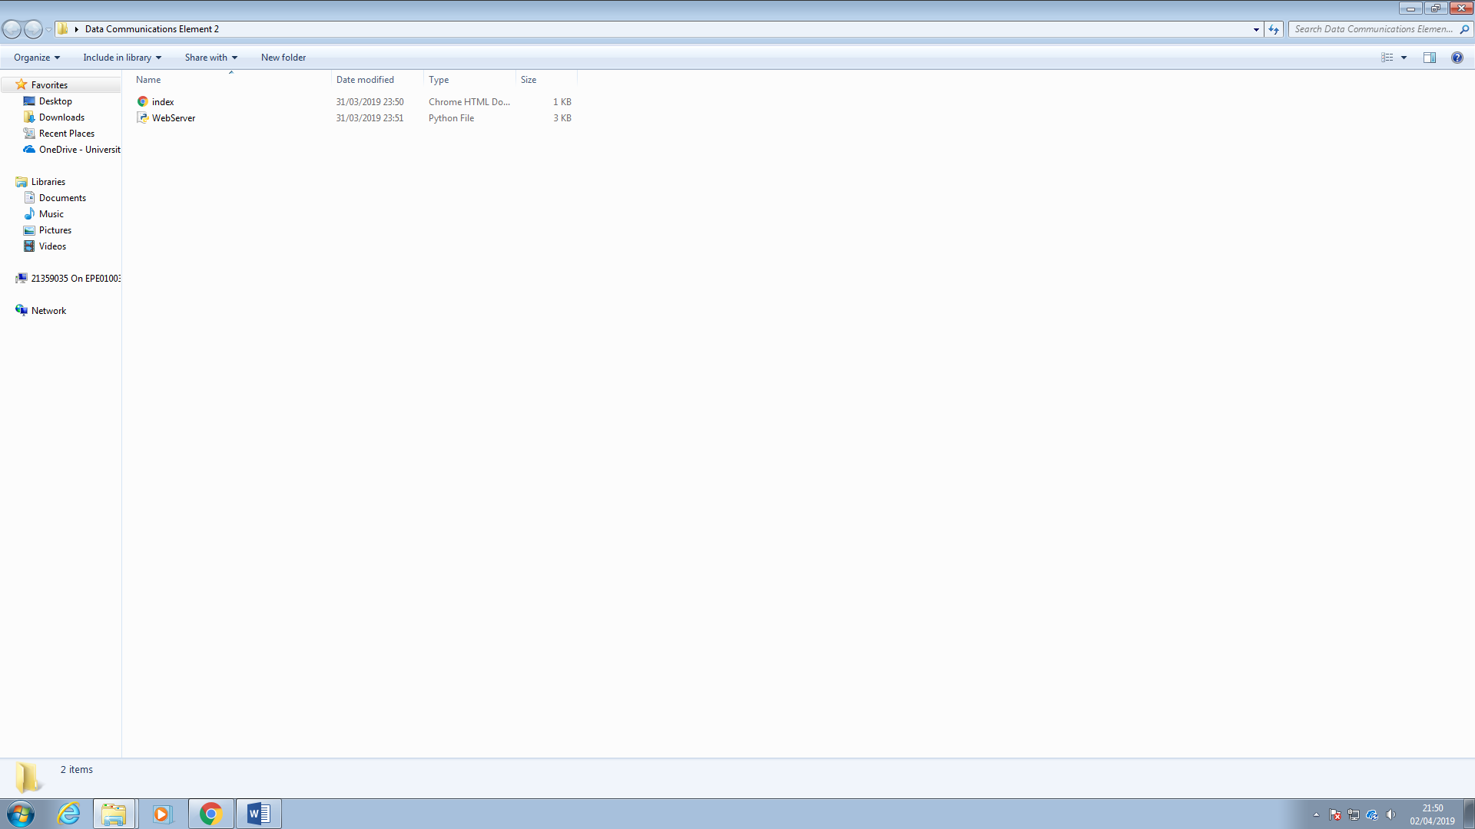

Here is the html file of the webpage in the same folder as the web server which is the server code in a programming language.

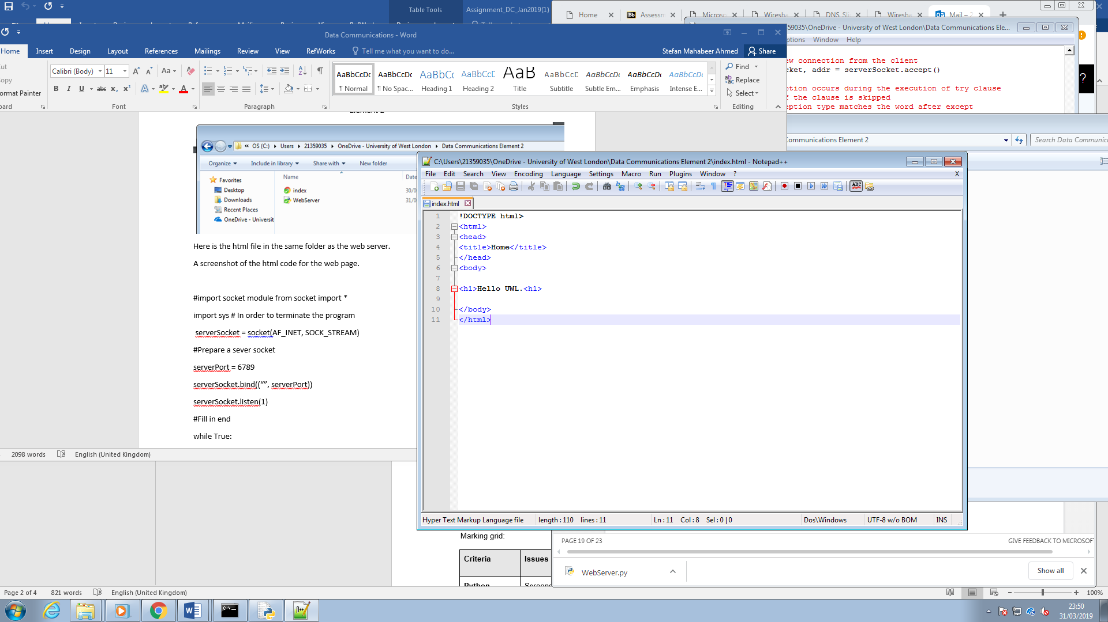

A screenshot of the html code for the web page.

Below is the actual programming code of the web server written in the programminglanguage known as Python.

#import socket module from socket import *

import sys # In order to terminate the program

serverSocket = socket(AF_INET, SOCK_STREAM)

#Prepare a sever socket and a port number for the server.

serverPort = 6789

# Bind the server socket to the server port

serverSocket.bind((“”, serverPort))

# Server socket starts listening which means it is ready to receive a connection which is in a queue as many as 1

serverSocket.listen(1)

#Fill in end

while True:

#Establish the connection

print('Ready to serve...')

# Create a connection to the client through a connection socket

connectionSocket, addr = serverSocket.accept()

try:

# Read the request sent by the client at the connection socket

message = connectionSocket.recv(1024)

# Split the message received at the connection socket and decode it

filename = message.split()[1]

f = open(filename[1:]).decode())

outputdata = f. read()

# Start sending a reply to the clients request

connectionSocket.send("HTTP/1.1 200 OK\r\n\r\n".encode())

#Send the requested file to the connection socket

for i in range(0, len(outputdata)):

connectionSocket.send(outputdata[i].encode())

connectionSocket.send("\r\n".encode())

#Close the connection socket to the client

connectionSocket.close()

except IOError:

#Send a response message if the file is not held by the server

connectionSocket.send("HTTP/1.1 404 Not Found\r\n\r\n".encode())

connectionSocket.send("<html><head></head><body><h1>404 Not Found</h1></body></html>\r\n".encode())

#Close the connection socket to the client

connectionSocket.close()

serverSocket.close()

sys.exit() #Terminate the program after sending the corresponding data

What the code above does

The code above is the code for the server. It makes the server receive the request from the client and send a message to client. To do that it first needs a connection socket created called the server socket and then a port number assigned to it using a variable called serverPort. The port number is binded to the server to create a connection to the client. The server starts listening to a request from the client. These number of client requests are in a queue as many as one. Once the server hears a request from the client a connection is ready and a connection to the client is made through a connection socket. The server prints a message ‘Ready to serve…’ when the server program code is being run with while being true.

A connection socket is created to connect to the client using the accept() method with the server socket. In the next part of the code starting with try the request sent by the client is read from the connection socket. A variable called message is then created with the clients port number 1024 being a parameter of the receive method .recv().

Before sending a response to the client the message, at the connection socket, is split and then decoded. It is then stored as output. A for loop is used to encode the response to the client and then send it through the connection socket to the client. If the requested web page file is not held by the server an exception error is sent displaying the message file Not Found.

The python web server code running. This screenshot indicates the server will be ready to serve…

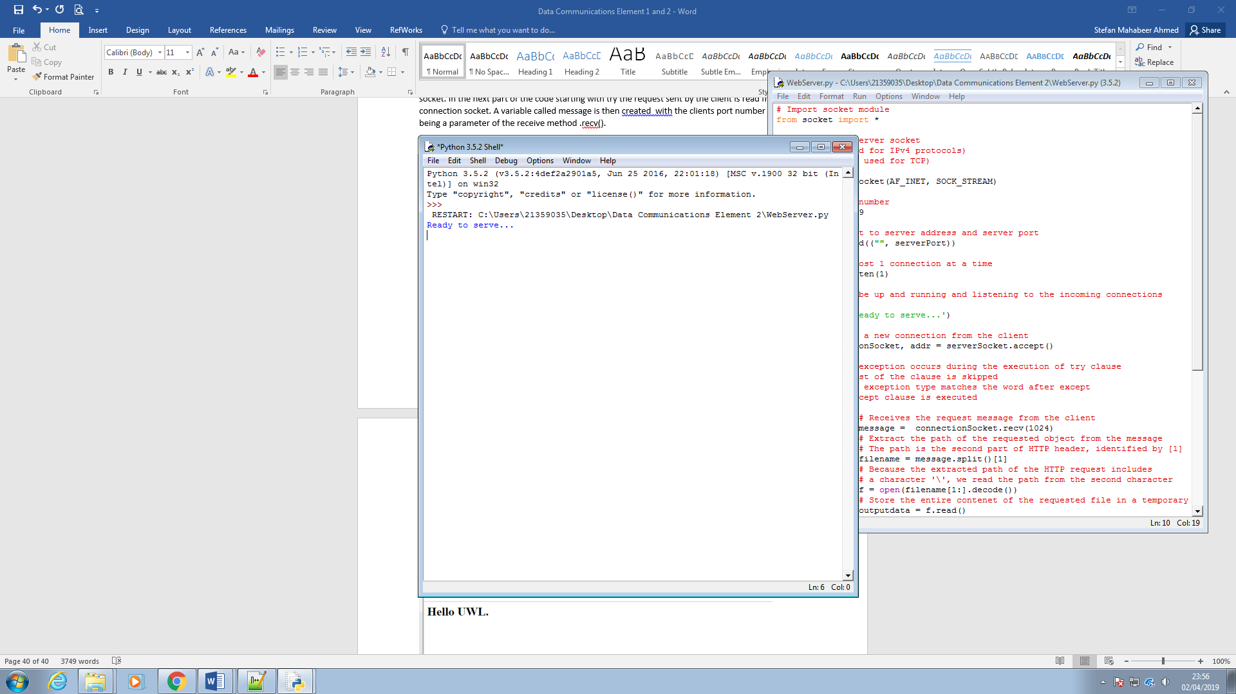

And here is the webpage running having used localhost followed by the port number and the name of the html file.

